BBT - Submission tool

Produced by the
Thesaurus Maintenance Working Group,
VCC3, DARIAH EU

Version 1.0 (draft)
Status: working document

June 2016

Contributors: Christos Georgis, Martin Doerr, Evagelia Daskalaki, Ilias Tzortzakakis, Chryssoula Bekiari

Table of Contents
Table of Contents 2
Introduction 3
1 BBT - Submission tool 4
1.1 Users 4
1.2 System functionality 5
1.3 User actions 6
1.3.1 Contributor actions 7
1.3.2 BBT-curator actions 7
1.3.3 Thesaurus domain expert actions 7
1.3.4 Administrator actions 7
1.3.5 Integration with external systems 7
1.4 Submission workflow 8
1.5 Submission status 9
1.6 Screenshots 11
1.7 Implementation details 14
1.7.1 System Architecture 14
1.7.2 System Platform 15
1.8 System Demonstrator 15

Introduction

In the report “DARIAH Backbone Thesaurus (BBT) Definition of a model for sustainable interoperable thesauri maintenance” , it is proposed a coherent overarching thesaurus for the humanities, a “backbone” or “metathesaurus”, under which all the vocabularies and terminologies in use in the domain can be aligned. The proposed approach is bottom-up; top-level concepts are developed by adequate abstraction from existing local terminological systems.
In the design report "Assisting Backbone Thesaurus maintenance”, we describe how to support all the stakeholders in this endeavor, by proposing a maintenance methodology, along with an assisting toolset that:
- enables independent local thesauri maintainers to create and maintain their thesauri, and at the same time incorporate them while still maintaining their independence, into a shared common thesaurus, that will be available to the public,
- enables the BBT curators of this common scheme of abstract concepts (hereafter BackBone Thesaurus, or BBT), to support and maintain the BBT, as a central thesaurus which would provide the general concepts under which local thesauri maintainers can attach/link their thesauri, and
- enables potential users (public, scientific community, etc.) to browse, navigate, visualize and use this very rich thesaurus that would incorporate the wealth of the different thesauri.
This document describes the methodology and tool (Submission tool) that enables independent local thesauri maintainers and potential BBT users (public, scientific community, etc.) to propose to the BBT curators new BBT concepts or modifications on the BBT existing concepts.

BBT - Submission tool
The BBT Submission tool is a communication system, developed by FORTH-ICS (www.ics.forth.gr), that supports discussions regarding the changes proposed for the BBT (changes related to concepts and their relations), hereafter called submissions. It keeps track of the different versions of the BBT and the history of the submissions (related past discussions). It also notifies all the interested parties, about the progress of a submission, and the release of the new versions of the BBT.
The BBT Submission Tool is used by local thesauri maintainers when they want to suggest changes for the BBT (contributors); it provides a form by which they can request modifications/additions/deletions regarding the concepts of the thesaurus. The tool is also used by the BBT-curators to browse and review submissions, and decide whether they agree to the suggested changes or disagree and ignore/reject/postpone them. The system also provides access to the previous versions of the thesaurus and the history of all the submissions in order to facilitate BBT-curator's job. The BBT-curators may also forward a submission to users that are experts in specific domains (thesaurus domain experts), for further consultation. Finally the tool is used by thesaurus domain experts that take part on specific change-related discussions.
System’s functionality described below is already implemented: the system is currently working on ontologies and would be adapted to work on thesauri. Since this document works as a design document we welcome any suggestions for added functionality or customizations on the existing one.

Users
The BBT Submission Tool can be accessed only with a valid username and password pair. Depending on the user’s role, he/she will have different rights. The different user-roles of the system are:
- Contributors (local thesauri maintainers or BBT-curators): The contributors are the persons who wish to comment or suggest changes on the BBT, requesting additions, deletions or modifications on the BBT concepts and their relations. The contributors submit requests for changes.
- BBT-curators: The BBT-curators are responsible for the maintenance of the BBT model. Their role is to make changes to the thesaurus model by consulting the submissions concerning the current thesaurus and the previous versions of the thesaurus. The BBT-curators have also the role of contributors: they can insert their own submissions into the system. Submissions can be forwarded to the thesaurus domain experts to be reviewed. They may also request clarification on a request from a contributor, or request the opinion of thesaurus domain experts regarding specific change request.
- Thesaurus domain experts: The thesaurus domain experts review submissions made or forwarded by the BBT-curators that are pertinent to their expertise (domain of knowledge), and respond back to the BBT-curators with proposed changes to the BBT.
- Administrators System: The System Administrators are responsible for the maintenance of the system information and the system software: manage the new users into the system, take and restore backups, etc.

System functionality
The system is accessed by users who want to suggest changes on the BBT model (contributors) and the BBT-curators, responsible for the maintenance of the BBT model. The system has access the thesaurus database maintained by the BBT management tool. Thus it has access to the current state of the thesaurus, all BBT previous versions, and maintain all their differences from version to version.
It provides contributors with forms for sending requests for modifications/additions/deletions on specific concepts or specific relations of the BBT model. The BBT-curators can browse through the submissions, review them and decide whether they agree to accept the suggested change or disagree and ignore/reject/postpone the change. To assist them in making their decisions the system provides the previous versions of the thesaurus and the history of all the submissions ever made in order to facilitate the work of BBT-curators. Figure 1, below, shows the Use Case diagram for the Submission. The submission workflow and coordination is described in detail in section 1.4.
The BBT-curators use the BBT management tool to implement the actual changes in the thesaurus database. After several minor or few major changes of the BBT model, a release of the BBT may be decided by the BBT-curators.
As a new version is created, all changes between the new and the previous version of the thesaurus are semi-automatically tracked (some of the changes may need to be manually identified by the BBT-curator). Now all past submissions follow the current version of the BBT. The mechanism described above enables the BBT Submission Tool to provide access to the previous versions of the thesaurus, the differences between versions and the history of all the submissions.
The BBT Submission Tool provides contributors with automatic feedback (in form of notifications) regarding the status of their submission and the status of the BBT: a new version of the thesaurus (a submission is made) is about to be (or is) released.
The system also allows the communication with external tools through specific web service functionality. It is able to receive new submissions and return the differences between versions (e.g. two subsequent versions of the BBT, or the history of a concept, or relation). As described in section 1.3.5.
NOTICE: Note that the BBT Submission Tool does not replace the BBT Management Tool (responsible for the maintenance of the BBT thesaurus database), nor the BBT Access Service (responsible for hosting and providing access to the current version the BBT). Its role is to gather requests for changes and assist the BBT-curators in making decisions about them, by providing access to the actual requests and by providing a point of reference of the changes of the thesaurus (by accessing previous BBT versions and the history of requests).

Figure 1: Use Case diagram for the Submission

User actions
By using the Submission system the contributors are able to search for a concept or a relation in the BBT, make a critic on it and put a request for a change. The system stores the history of the dialogue between the contributors and the BBT-curators and inform all the interested parties when a change on the thesaurus has occurred or a new version of the thesaurus has been released. All the interested parties are kept up to date, by receiving e-mail from the system.
The functionalities of the system for each of the user-roles are the presented in the following sections.

Contributor actions
Contributors can:
- Submit a request for change in the BBT model. The contributors can submit a request for adding, deleting, or modifying a concept in the BBT model. The system provides a form where the user has to fill in the following information: name, definition (scope notes), context of use, justification, and example.
- Search for a concept
- View a concept
- Search for a submission
- View a submission
- List pending explanation-requests
- View a pending explanation-request
- Reply to a pending explanation on a submission

BBT-curator actions
The BBT-curators are the only users who have the full “view” of the system: they have all the rights and permissions on the informational parts of the system. That means that he has all the functions available to the contributor as well as:
- View the history of a concept
- Send an explanation-request
- List pending or replied explanation-requests
- List all pending explanation-requests for reply
- Insert a new Version of the BBT history
- Request for an expert opinion on a submission to the domain expert
- Request for clarification on a submission to a contributor
- Change the status of a submission

Thesaurus domain expert actions
The domain expert has the same functions as the contributor.

Administrator actions
- Manage the accounts
- System backup/restore

Integration with external systems
The system is designed to support interaction with other external tools, by using web services technology, which allows the systems to communicate with each other without intimate knowledge of each other’s internal behaviour or technology.
The available functions that the system provides via web services are listed below:
- Add a new submission into the system
- Return the table of differences between two subsequent versions, as the BBT-curator has marked them
- Return the history of a concept (all the concept differences from version to version)
Since this document works as a design document we welcome any suggestions for added functionality or customizations on the existing one.

Submission workflow
When inserting a new change request (submission) into the system the contributor receives automatic response that certifies the submission. Once this is done, the new submission is inserted into the system’s submission pool. Notifications on the new submissions are sent by e-mail to the BBT-curators, in order to inform them for the new change requests. Furthermore the BBT-curators can see the new submissions in the system by accessing a specific area (page) in their system workspace. The process that is followed after a new submission is described below:
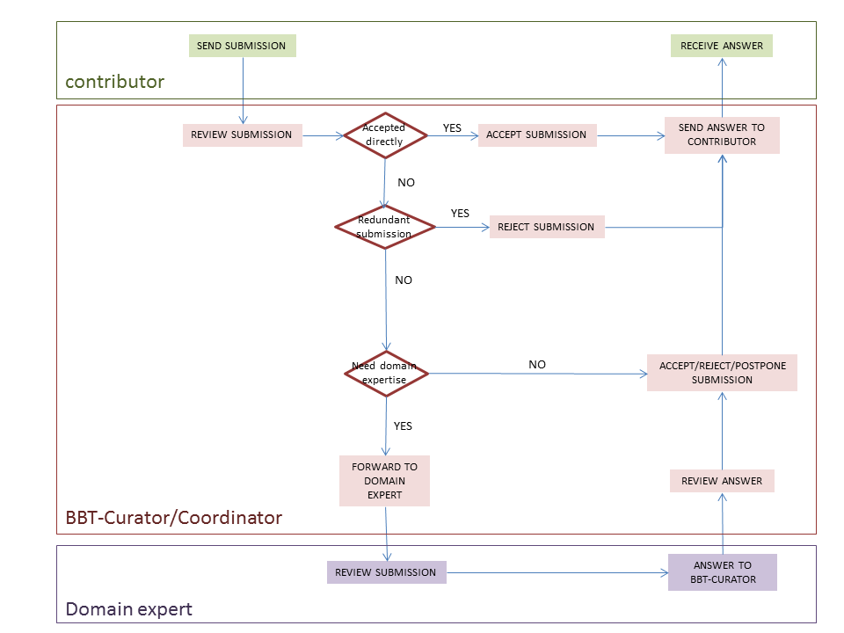
Figure 2: Activity Diagram of the submission workflow
When the new submission is inserted, the BBT-coordinating-curator may check whether the submission is redundant, or not, and initiate the discussion on the proposed change, by welcoming the other BBT-curators to review the new submission. If the submission is directly accepted, the BBT-coordinating-curator implements the change into the BBT thesaurus database using the BBT Management Tool. Otherwise the submission is rejected, postponed or beyond BBT-curators’ expertise. If the BBT-curators consider that the submission is beyond their expertise, they may send it to the thesaurus domain expert (invite him/her in the discussion). The thesaurus domain expert will be informed by e-mail for the submission. After the thesaurus domain expert checks the submission, he/she state his/her opinion on the change. The BBT-curators review the domain expert’s answer, and again decide to accept, reject, or postpone the submission. In all cases the contributors are informed by e-mail about the progress of their submissions. In Figure 2, above, you can see the activity diagram of the submission workflow. Although it is not presented in the diagram, a discussion may contain many iterations of discussions. The BBT-coordinating-curator may end the discussion (e.g. concluding that a common agreement is reached or by asking a voting to take place, etc.). Once a decision on a change is made they are responsible to implement the change into the BBT thesaurus database using the BBT Management Tool.
The BBT-curators are also responsible to decide upon the publication of a new version of BBT model: a new version of BBT may include several changes of the BBT. In order for an official version of the BBT model to be released, the BBT-curators use the BBT Management Tool to implement any pending changes in the thesaurus database. Then they export official version of the BBT model from the BBT Management Tool in two forms: the BBT Definition Document (the official textual description of the BBT model) and the BBT LOD model (a SKOS RDF document). The new version of BBT LOD model should be sent to the BBT – Thesaurus Access tool to be loaded and to be publicly accessible (by the BBT access providers).

Submission status
Submissions have statuses that can be changed by the selected user actions. They are listed below (see also Figure 3):
- Submitted (pending): It is the first status of a change request. Once the contributor sends a submission it takes the status “Submitted”. This status shows that the submission has not been checked from the BBT-curator.
- Under discussion, wait for reply: After the submission the BBT-coordinating-curator checks the submission, he might need some explanations or even more information about the submission. If that is the case, then he sends a submission back to the contributor and the submission is taking the status “Under discussion, wait for reply”.
- Under discussion, replied: The contributor reviews the received submissions and replies giving explanations or more information about the submission. The submission gets the status “Under discussion, replied”.
- Implementation: When a submission has the status “Implementation”, it means that the BBT-coordinating-curator is introducing the change into the thesaurus database using the BBT Management Tool.
- Wait for release: After the BBT-coordinating-curator introduced the into the thesaurus database, he/she changes the submission status to “Wait for release”. During this phase, changes may still occur to the submission until it comes to its final state.
- Released: A new official version of the BBT model is released, all submissions with status “Wait for release” change to “Released” and all the interested parties have been informed about the final status of the request for change.
- Postponed: The request for change will be reviewed later in time.
- Rejected: The request for change is considered as not implementable or implementable in the future, and all the parties are informed.
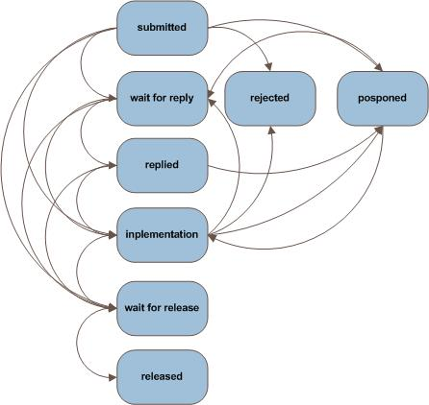
Figure 3: Sequence Diagram, of the submission statuses.

Screenshots
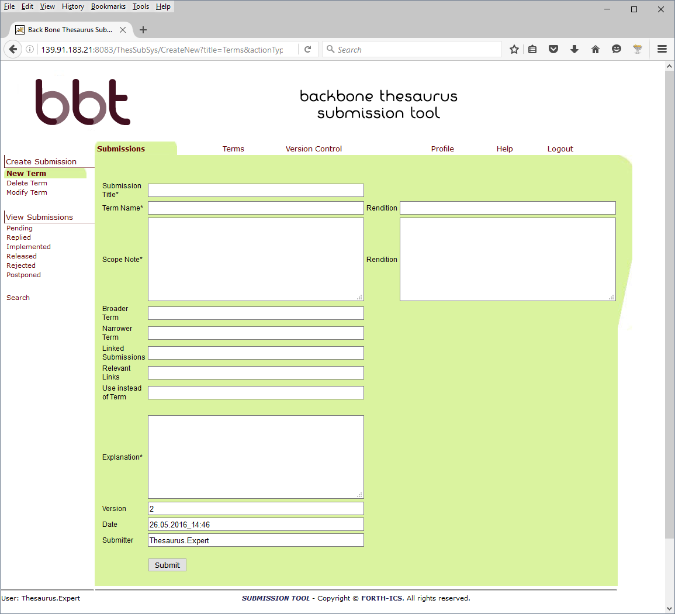
Figure 4: Make a submission to create a New BBT Concept (New Term)
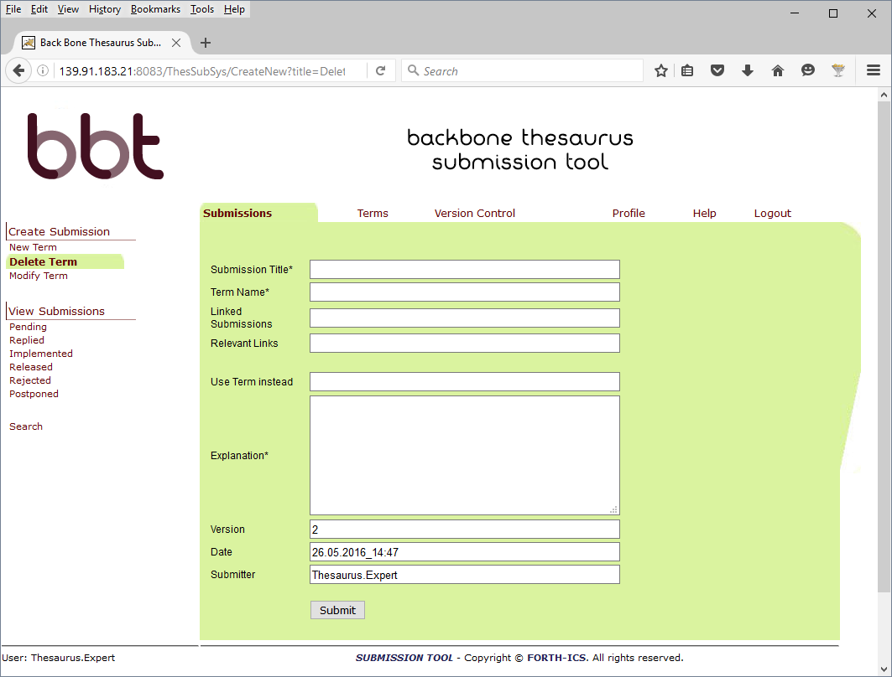
Figure 5: Make a submission to delete a BBT Concept (Delete Term)

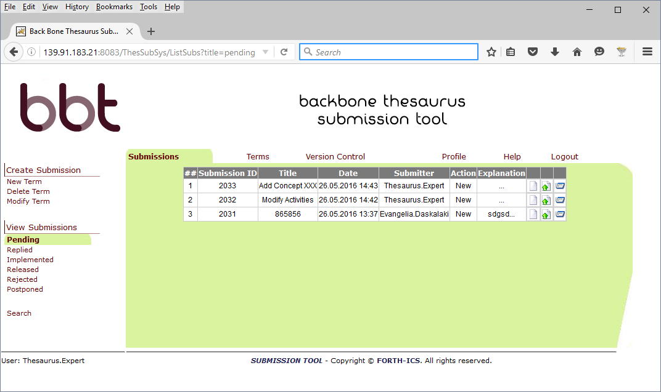
Figure 6: List all pending submissions

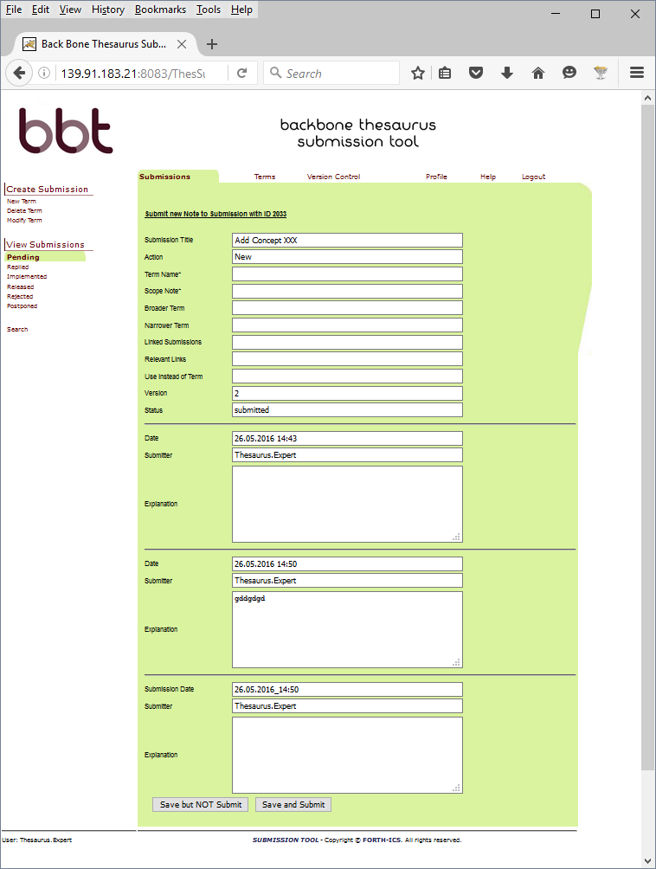Figure 7: View a submission history

Implementation details

System Architecture
The system is developed on a 3-tier architecture, which allows us to create a modular code that can be easily maintained and expanded.
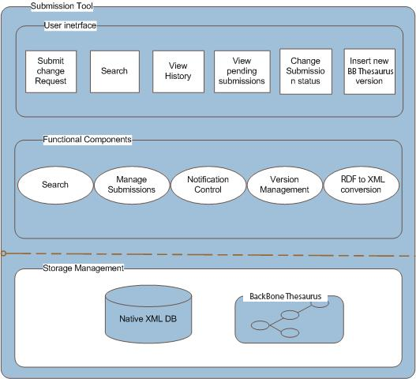
Figure 8: System Architecture
Storage management
The storage management module includes a XML Database where all the converted XML documents, the XML submission files as well as the configuration files for the users, the permissions, the Queries and all the versions of the BBT are stored. Each version of the BBT includes the thesaurus information in an RDF (SKOS) document. The system contains a copy of the current state of the thesaurus (the thesaurus, a SKOS RDF document, is digested into the system in form of XML file(s), containing the description of concepts and relations between concepts).
User interface
The user interface includes the interaction components that contributors, BBT-curators and domain experts use for the change requests, along with change-request reviewing and thesaurus versioning reviewing and the search. Notice that the actions provided to the users depend on the users’ role. This front-end of the system provides users with clear view of the operations available for the specific documentation stage. The system’s functionality is invoked with simple user actions, such as button selections etc.
Functional components
The functional components constitute the basic mechanism that incorporates all the system’s intelligence. It includes various functional modules such as the search mechanism for the submissions, search mechanism for the Concepts, the mechanism for adding a new submission, the permissions management component, the notification control mechanism, the version Management component, the RDF to XML conversion module, etc. These modules are invoked by user actions or through the interaction with other modules and react with the storage mechanism.

System Platform
Web Application Server and Web-browser
The Submission system is a web based on-line application, which is based on client-server architecture. As mentioned earlier, the system is developed using J2EE technology, on a 3-tier architecture, which allows us to create modular code that can be easily maintained and expanded. It is accessible to every user who owns a login account. The only prerequisites for using the tool are access to the World Wide Web (Internet) and a Web Browser (e.g. Internet Explorer, Mozilla Firefox, etc.).
Database
The system Database stores XML documents that have been produced from the conversion of the RDF (SKOS) document, the XML submission documents that include all the history of the concepts of the BBT, the requests for changes, as well as the stored Queries for the users, the configuration files for the user permissions etc.
We have chosen eXist Native XML DB, as our system database. The choice has been made based on the following criteria: documentation, reputation, encoding support, interface capability with other systems, as well as the cost (open source).
Operating system
The Submission system Application Server is developed and operated on a Windows Operating system, but we expect to run smoothly on any operating system since the underlying technologies are running on any operating system.

System Demonstrator
- Web Application http://139.91.183.21:8083/ThesSubSys
For login details please contact georgis@ics.forth.gr or bekiari@ics.forth.gr

“DARIAH Backbone Thesaurus (BBT) Definition of a model for sustainable interoperable thesauri maintenance”, produced by Thesaurus Maintenance Working Group, VCC3, DARIAH EU, Version 1.1, January 2016.
If the list of the possible changes of concepts is not fully defined we welcome any suggestions to complete it.

