Assisting Backbone Thesaurus maintenance

Methodology and Infrastructure

Produced by the
Thesaurus Maintenance Working Group,
VCC3, DARIAH EU

Version 1.0
Status: working document

June 2016

Contributors: Christos Georgis, Martin Doerr, Evagelia Daskalaki, Ilias Tzortzakakis, Chryssoula Bekiari, Maria Daskalaki, Lida Charami, Helen Katsiadaki, Helen Goulis, Hella Hollander, Matej Durco, Vanessa Hannesschläger, Wolfgang Schmidle, and others

Table of Contents
Table of Contents 2
Introduction 3
1 Objects, Actors and Proposed Workflow 4
1.1 Handled objects 4
1.2 Involved parties 4
1.3 Overall Workflow 5
2 Proposed tools 7
2.1 BBT - Thesaurus Access tool 7
2.2 BBT – Thesaurus Maintenance tool 8
2.3 BBT - Submission Tool 8
2.3.1 Users 8
2.3.2 System functionality 9
2.3.3 User actions 11
2.3.3.1 Contributor actions 11
2.3.3.2 BBT-curator actions 11
2.3.3.3 Thesaurus domain expert actions 11
2.3.3.4 Administrator actions 12
2.3.3.5 Integration with external systems 12
2.3.4 Submission workflow 12
2.3.5 Submission status 13
2.3.6 Screenshots 15
2.3.7 Implementation details 18
2.3.7.1 System Architecture 18
2.3.7.2 System Platform 19
2.3.8 System Demonstrator 19
2.4 Thesaurus federation viewer 19

Introduction

The aim of this work is to design and develop a maintenance methodology, along with a toolset to assist that methodology, following the proposal of how existing thesauri and ontologies will become interoperable and can be maintained in a sustainable and scalable way. This work follows the work proposed in the report “A model for sustainable interoperable thesauri maintenance” . This model proposal has been undertaken by the Thesaurus Maintenance WG which was established in 2014 in the framework of DARIAH EU: The Digital Research Infrastructure for the Arts and Humanities - a research infrastructure. This Research Infrastructure aims at enhancing and supporting digitally-enabled research and teaching across the arts and humanities.
The idea proposed in the above report is to design and establish a coherent overarching thesaurus for the humanities, a “backbone” or “metathesaurus”, under which all the vocabularies and terminologies in use in the domain can be aligned. The proposed approach is bottom-up; top-level concepts are developed by adequate abstraction from existing local terminological systems.
We need to support all the stakeholders in this endeavor, by proposing a maintenance methodology, along with an assisting toolset that would:
- enable independent local thesauri maintainers to create and maintain their thesauri, and at the same time incorporate them, while still maintaining their independence, into a shared common thesaurus, that will be available to the public.
- enable the curators of this common scheme of abstract concepts (hereafter BackBone Thesaurus, or BBT), to support and maintain the BBT, as a central thesaurus which would provide the general concepts under which local thesauri maintainers can attach/link their thesauri.
- enable potential users (public, scientific community, etc.) to browse, navigate, visualize and use this very rich thesaurus that would incorporate the wealth of the different thesauri.

Objects, Actors and Proposed Workflow

Handled objects
Local thesauri existing (or new) thesauri and ontologies, independently developed and maintained. These thesauri that would like to become part of a coherent overarching thesaurus for the humanities, a “backbone” or “metathesaurus”, under which all the vocabularies and terminologies in use in the domain can be aligned.
BackBone Thesaurus (BBT) is a coherent overarching thesaurus for the humanities, the “backbone” or “metathesaurus”, under which all the vocabularies and terminologies (local thesauri) in use in the domain can be aligned. The BBT model is maintained in a thesaurus database with the use of BBT management tool. The official description of the BBT model is automatically exported from the BBT management tool database, in two forms:
- the BBT Definition Document, that describes the BBT model in textual form. In the appendix are described all changes between the current and the previous versions of BBT.
- the BBT LOD representation of the BBT model (SKOS RDF description), which is available through a service: BBT Access Service. A thesaurus system (software) hosts and provides public access to the official BBT LOD version. This system maintains consistent identification (LOD identification) for all concepts of the BBT, in order to be referenced by the local thesauri, or to be accessed by the public.
DARIAH Thesaurus Federation (ΒΒΤ and Local thesauri) is the federated thesaurus for the humanities, which comprises the BBT and all the local thesauri that are aligned with the BBT.

Involved parties
Local thesauri maintainers may already have built one (or more) thesaurus(ri) or wish to create a new one. We do not intent to interfere with the existing thesaurus creation workflows or practices, but we, nevertheless, need to have a basic agreement regarding the basic concepts and their generalizations/ specializations as represented in the “backbone thesaurus”. Currently the Deutsches Archäologisches Institut, (DAI, http://www.dainst.org/el) uses the BBT (version 1), and discusses questions and proposals of improvement of the BBT with the BBT curators.
BBT-curators is the group of thesaurus experts responsible for changes in the BBT model. They take requests for changes, regarding concepts, from different users of the BBT and decide upon their validity. Among the BBT-curators there is a curator that coordinates the group (BBT-coordinating-curator); for instance he is responsible to select a submission regarding a change and initiate the discussion on this change, and also to end the discussion (e.g. concluding that a common agreement is reached or by asking a voting to take place, etc.). Once a decision on a change is made they are responsible to introduce the change to the BBT model using the BBT management tool. BBT-curators are also responsible to decide on the publication of a new version of BBT model, by making available the BBT Definition Document (the official description of the BBT model) and the BBT LOD model (a SKOS RDF document). Currently the BBT-curators are the members of the Thesaurus Maintenance Working Group, VCC3, DARIAH EU and the BBT management tool used is Synthesis (https://www.ics.forth.gr/isl/index_main.php?l=e&c=271).
BBT access providers are responsible to host and provide access to the current version the BBT. They load the exported BBT LOD model (RDF description) to the BBT Access Service thus exposing the current official BBT version to the public and maintaining consistent identification (LOD identification) for all concepts of the BBT, in order to be referenced by the local thesauri. Currently the BBT access providers are ACDH-OEAW members (http://www.oeaw.ac.at/acdh) and the BBT - thesaurus access tool used is OpenSKOS (http:/openskos.org/).
Potential thesaurus users (public, scientific community, etc.) are the users of all the vocabularies and terminologies that are (or could be) aligned under the BBT. These users should be provided with tools that browse, navigate, visualize and use this very rich thesaurus infrastructure that would incorporate the wealth of all the different thesauri in the DARIAH Thesaurus Federation.

Overall Workflow
We propose the following workflow:
- Making requests for BBT changes. The BBT is expected to get updated or extended with the addition of new concepts. Local thesaurus maintainers, and BBT-curators alike, may suggest changes in the BBT (modification, addition, or deletion of concepts of the BBT). We propose the use of a tool (BBT Submission Tool) that would facilitate submission of such requests and would also enable the discussion on such requests, hereafter also called submissions.
- Deciding upon requests for BBT changes. Since the BBT is a common thesaurus scheme, any change (modification, addition, or deletion) has to be commonly decided by the BBT-curators. The BBT-curators will use the BBT Submission Tool in the decision making process: while processing a submitted change the BBT-curators might need to review past discussions regarding the proposed change, in order to accept, reject or postpone it. They might also need to go back in the BBT version history and consult the differences between the different BBT versions. The BBT Submission Tool will keep track of the different versions of the BBT and the history of the submissions (related past discussions). Notice that in this process BBT-curators may also forward a submission to third parties (external to WG) that are considered to be experts in specific domains (thesaurus-domain experts), for further consultation. These experts will also use BBT Submission Tool and take part in specific change-related discussions.
- Making a BBT change. After a change is approved and agreed upon, the BBT-curators will have to introduce the change into the database using the BBT Management Tool. Since the BBT Submission Tool keeps track of all the involved parties in the discussion, it will also notify them, about the progress of a submission, as well as the release of the new versions of the BBT (see below).
- Publishing a BBT new version. The BBT-curators will use BBT Management Tool to update the current BBT version in the thesaurus database. A new version of BBT may include several minor or few major changes of the BBT. The BBT-curators are responsible to decide upon the publication of a new version of BBT. Once decided, an official version of the BBT is released: both the BBT Definition Document (the official textual description of the BBT model) and the BBT LOD model (a SKOS RDF document) are exported and made public (the new BBT LOD model is loaded and made accessible by the BBT Access Service). Exposing the new BBT version to the public requires that consistent identification (LOD identification) is maintained for all concepts of the BBT, in order to be referenced by the local thesauri, without loss of their referential integrity. Publishing a new version of the BBT may also affect the local thesauri that are linked to BBT, therefore we propose that local thesauri maintainers should be notified as described below.
- Linking local thesauri with BBT. Local thesauri maintainers create their own local thesauri, using their own workflow and software. We encourage local thesaurus maintainers to use concepts from BBT as top-concepts in their thesauri. This will enable the alignment of their vocabularies and terminologies (thesauri) under one shared thesaurus, the BBT.
The first step in linking local thesauri with the BBT in general means deciding which of the upper level concepts of the local thesauri should classified under the general concepts of the BBT. This should be performed only by the local thesaurus maintainers. We propose, that local thesauri maintainers should include in their local thesauri general BBT concepts, by using local “clone” concepts (declared as “same as” / “exact equivalence” to the BBT concepts, by their LOD identifiers as these are provided by the BBT Access Service). This would constitute a one-direction link from the local thesaurus to the BBT. Additionally we propose a second link to be created, originating from the BBT concept to its clone in the local thesauri. This would be possible by providing a service from the BBT – Thesaurus Access tool, that will create this link (LOD identification of the local thesaurus concept which is declared as “same as” the BBT concept) and also will store contact information of the local thesauri maintainers in order to keep them updated for changes on the specific BBT concept (e.g. contact e-mail, organization info, etc.).
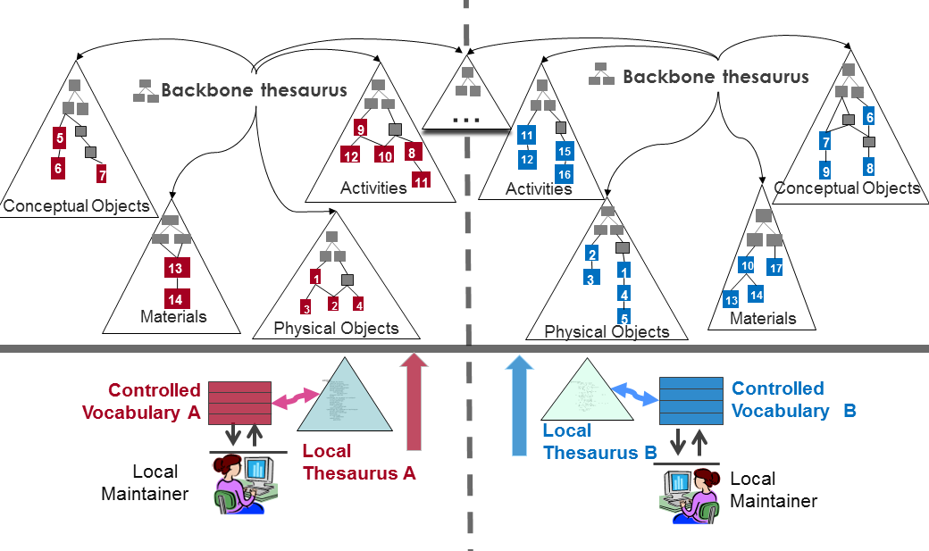
Figure 1: Linking to the BBT
- Notifying local thesauri maintainers about new BBT version changes that may affect them. We propose that BBT - Thesaurus Access tool should also include a service that would notify the local thesauri maintainers about changes in the new version of BBT that may affect them. For instance, if a BBT concept is modified (e.g. its scope note is updated, thus its meaning is altered), all local thesauri developed that are linked to the specific BBT concept as a top-concepts in their thesauri, should be notified about the change in order to verify if the specific change affects their local thesauri.
- Unlinking local thesauri from the BBT. Local thesauri maintainers may also decide to un-link their thesauri from BBT. For that, they should remove the local “clone” concepts (declared as “same as” to the BBT concepts (removal of the one-direction link from the local thesaurus to the BBT). Additionally removing the second link could be possible by providing a service (from the BBT - Thesaurus Access tool) that would remove the link originating from the BBT concept to its clone in the local thesauri and would also remove the related local thesauri maintainers contact information.
- General requirements
  - All thesauri (local and BBT) should use consistent LOD identifiers for referencing concepts and their relations. These identifiers should not change across thesauri versions.
  - All tools should be able to export and import data (thesauri, or parts of thesauri) in SKOS format, under a scheme that is currently under discussion. This scheme should be described in detailed and later be part of this report.
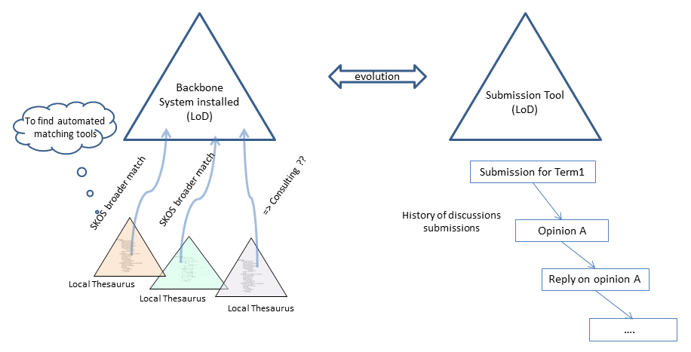
Figure 2: BBT Management Tool and BBT Submission Tool

Proposed tools
The following sections give an overview of the proposed infrastructure-components / tools and we describe their basic features.

BBT - Thesaurus Access tool
This is the tool responsible for hosting and providing access to the current version the BBT. It includes a service to expose the current official BBT version to the public (BBT Access Service). It should provide consistent identification (LOD identification) for all concepts of the BBT, in order to be referenced by the local thesauri.
Currently the proposed BBT - thesaurus access tool used is OpenSKOS (http://openskos.org), developed by ACDH-OEAW (www.oeaw.ac.at/acdh). It runs as a service for the research community in the context of research infrastructures CLARIN-ERIC and DARIAH-EU. It comprises of: the thesaurus browser (may be used as the proposed BBT Access Service), which provides an overview of the concepts (and concept schemes) (see also https://clarin.oeaw.ac.at/vocabs/browser) and the editor for manual updates (see also https://clarin.oeaw.ac.at/vocabs/editor/login).
Once decided, that an official version of the BBT model should be released, the BBT LOD model (SKOS RDF document) is exported from the BBT management tool and made public (the new BBT LOD model is loaded and made accessible by the BBT Access Service). Publishing a new version of the BBT may also affect the local thesauri that are linked to BBT, therefore we propose that local thesauri maintainers should be notified.
As mentioned earlier we have proposed some additional functionality that mainly consist of (a) a service for creating (and removing) links originating from BBT concepts to local thesauri concepts (LOD identified), (b) the storage of contact info, (c) along with a notification mechanism. Finally an export to SKOS of the BBT is needed to be triggered by the BBT Submission Tool in order to get the current SKOS version of BBT to update tool’s BBT version history.

BBT – Thesaurus Maintenance tool
This is the tool responsible for thesaurus management (BBT management tool) to maintain the BBT thesaurus database. It should communicate with the BBT Access Service to ensure consistent identification (LOD identification) for all concepts of the BBT, in order to be referenced by the local thesauri.
The proposed BBT - thesaurus maintenance tool is based on Synthesis system (https://www.ics.forth.gr/isl/index_main.php?l=e&c=271), a cultural information system for scientific and administrative documentation, developed by FORTH-ICS (www.ics.forth.gr) that will maintain the BBT thesaurus database.
This tool will be used by the BBT-curators who maintain the BBT model. Once decided, that an official version of the BBT model should be released: both the BBT Definition Document (the official textual description of the BBT model) and the BBT LOD model (a SKOS RDF document) are exported from the BBT management tool and are made public. The new version of BBT LOD model should be sent to the BBT – Thesaurus Access tool to be loaded and to be publicly accessible.

BBT - Submission tool
The BBT Submission tool is a communication system, developed by FORTH-ICS (www.ics.forth.gr), that supports discussions regarding the changes proposed for the BBT (changes related to concepts and their relations), hereafter called submissions. It keeps track of the different versions of the BBT and the history of the submissions (related past discussions). It also notifies all the interested parties, about the progress of a submission, and the release of the new versions of the BBT.
The BBT Submission Tool is used by local thesauri maintainers when they want to suggest changes for the BBT (contributors); it provides a form by which they can request modifications/additions/deletions regarding the concepts of the thesaurus. The tool is also used by the BBT-curators to browse and review submissions, and decide whether they agree to the suggested changes or disagree and ignore/reject/postpone them. The system also provides access to the previous versions of the thesaurus and the history of all the submissions in order to facilitate BBT-curator's job. The BBT-curators may also forward a submission to users that are experts in specific domains (thesaurus domain experts), for further consultation. Finally the tool is used by thesaurus domain experts that take part on specific change-related discussions.
System’s functionality described below is already implemented: the system is currently working on ontologies and would be adapted to work on thesauri. Since this document works as a design document we welcome any suggestions for added functionality or customizations on the existing one.

Users
The BBT Submission Tool can be accessed only with a valid username and password pair. Depending on the user’s role, he/she will have different rights. The different user-roles of the system are:
- Contributors (local thesauri maintainers or BBT-curators): The contributors are the persons who wish to comment or suggest changes on the BBT, requesting additions, deletions or modifications on the BBT concepts and their relations. The contributors submit requests for changes.
- BBT-curators: The BBT-curators are responsible for the maintenance of the BBT model. Their role is to make changes to the thesaurus model by consulting the submissions concerning the current thesaurus and the previous versions of the thesaurus. The BBT-curators have also the role of contributors: they can insert their own submissions into the system. Submissions can be forwarded to the thesaurus domain experts to be reviewed. They may also request clarification on a request from a contributor, or request the opinion of thesaurus domain experts regarding specific change request.
- Thesaurus domain experts: The thesaurus domain experts review submissions made or forwarded by the BBT-curators that are pertinent to their expertise (domain of knowledge), and respond back to the BBT-curators with proposed changes to the BBT.
- Administrators System: The System Administrators are responsible for the maintenance of the system information and the system software: manage the new users into the system, take and restore backups, etc.

System functionality
The system is accessed by users who want to suggest changes on the BBT model (contributors) and the BBT-curators, responsible for the maintenance of the BBT model. The system has access the thesaurus database maintained by the BBT management tool. Thus it has access to the current state of the thesaurus, all BBT previous versions, and maintain all their differences from version to version.
It provides contributors with forms for sending requests for modifications/additions/deletions on specific concepts or specific relations of the BBT model. The BBT-curators can browse through the submissions, review them and decide whether they agree to accept the suggested change or disagree and ignore/reject/postpone the change. To assist them in making their decisions the system provides the previous versions of the thesaurus and the history of all the submissions ever made in order to facilitate the work of BBT-curators. Figure 3, below, shows the Use Case diagram for the Submission. The submission workflow and coordination is described in detail in section 2.3.4.
The BBT-curators use the BBT management tool to implement the actual changes in the thesaurus database. After several minor or few major changes of the BBT model, a release of the BBT may be decided by the BBT-curators.
As a new version is created, all changes between the new and the previous version of the thesaurus are semi-automatically tracked (some of the changes may need to be manually identified by the BBT-curator). Now all past submissions follow the current version of the BBT. The mechanism described above enables the BBT Submission Tool to provide access to the previous versions of the thesaurus, the differences between versions and the history of all the submissions.
The BBT Submission Tool provides contributors with automatic feedback (in form of notifications) regarding the status of their submission and the status of the BBT: a new version of the thesaurus (a submission is made) is about to be (or is) released.
The system also allows the communication with external tools through specific web service functionality. It is able to receive new submissions and return the differences between versions (e.g. two subsequent versions of the BBT, or the history of a concept, or relation). As described in section 2.3.3.5.
NOTICE: Note that the BBT Submission Tool does not replace the BBT Management Tool (responsible for the maintenance of the BBT thesaurus database), nor the BBT Access Service (responsible for hosting and providing access to the current version the BBT). Its role is to gather requests for changes and assist the BBT-curators in making decisions about them, by providing access to the actual requests and by providing a point of reference of the changes of the thesaurus (by accessing previous BBT versions and the history of requests).

Figure 3: Use Case diagram for the Submission

User actions
By using the Submission system the contributors are able to search for a concept or a relation in the BBT, make a critic on it and put a request for a change. The system stores the history of the dialogue between the contributors and the BBT-curators and inform all the interested parties when a change on the thesaurus has occurred or a new version of the thesaurus has been released. All the interested parties are kept up to date, by receiving e-mail from the system.
The functionalities of the system for each of the user-roles are the presented in the following sections.

Contributor actions
Contributors can:
- Submit a request for change in the BBT model. The contributors can submit a request for adding, deleting, or modifying a concept in the BBT model. The system provides a form where the user has to fill in the following information: name, definition (scope notes), context of use, justification, and example.
- Search for a concept
- View a concept
- Search for a submission
- View a submission
- List pending explanation-requests
- View a pending explanation-request
- Reply to a pending explanation on a submission

BBT-curator actions
The BBT-curators are the only users who have the full “view” of the system: they have all the rights and permissions on the informational parts of the system. That means that he has all the functions available to the contributor as well as:
- View the history of a concept
- Send an explanation-request
- List pending or replied explanation-requests
- List all pending explanation-requests for reply
- Insert a new Version of the BBT history
- Request for an expert opinion on a submission to the domain expert
- Request for clarification on a submission to a contributor
- Change the status of a submission

Thesaurus domain expert actions
The domain expert has the same functions as the contributor.

Administrator actions
- Manage the accounts
- System backup/restore

Integration with external systems
The system is designed to support interaction with other external tools, by using web services technology, which allows the systems to communicate with each other without intimate knowledge of each other’s internal behaviour or technology.
The available functions that the system provides via web services are listed below:
- Add a new submission into the system
- Return the table of differences between two subsequent versions, as the BBT-curator has marked them
- Return the history of a concept (all the concept differences from version to version)
Since this document works as a design document we welcome any suggestions for added functionality or customizations on the existing one.

Submission workflow
When inserting a new change request (submission) into the system the contributor receives automatic response that certifies the submission. Once this is done, the new submission is inserted into the system’s submission pool. Notifications on the new submissions are sent by e-mail to the BBT-curators, in order to inform them for the new change requests. Furthermore the BBT-curators can see the new submissions in the system by accessing a specific area (page) in their system workspace. The process that is followed after a new submission is described below:
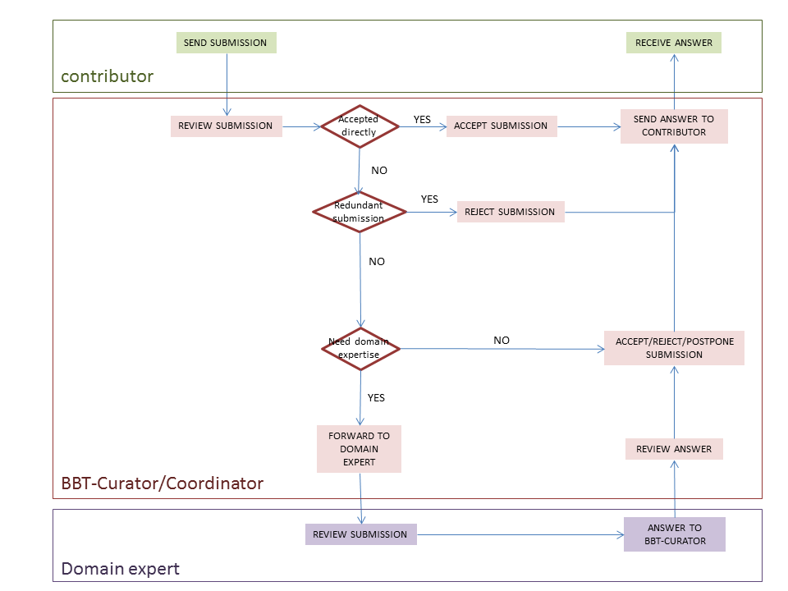
Figure 4: Activity Diagram of the submission workflow
When the new submission is inserted, the BBT-coordinating-curator may check whether the submission is redundant, or not, and initiate the discussion on the proposed change, by welcoming the other BBT-curators to review the new submission. If the submission is directly accepted, the BBT-coordinating-curator implements the change into the BBT thesaurus database using the BBT Management Tool. Otherwise the submission is rejected, postponed or beyond BBT-curators’ expertise. If the BBT-curators consider that the submission is beyond their expertise, they may send it to the thesaurus domain expert (invite him/her in the discussion). The thesaurus domain expert will be informed by e-mail for the submission. After the thesaurus domain expert checks the submission, he/she state his/her opinion on the change. The BBT-curators review the domain expert’s answer, and again decide to accept, reject, or postpone the submission. In all cases the contributors are informed by e-mail about the progress of their submissions. In Figure 4, above, you can see the activity diagram of the submission workflow. Although it is not presented in the diagram, a discussion may contain many iterations of discussions. The BBT-coordinating-curator may end the discussion (e.g. concluding that a common agreement is reached or by asking a voting to take place, etc.). Once a decision on a change is made they are responsible to implement the change into the BBT thesaurus database using the BBT Management Tool.
The BBT-curators are also responsible to decide upon the publication of a new version of BBT model: a new version of BBT may include several changes of the BBT. In order for an official version of the BBT model to be released, the BBT-curators use the BBT Management Tool to implement any pending changes in the thesaurus database. Then they export official version of the BBT model from the BBT Management Tool in two forms: the BBT Definition Document (the official textual description of the BBT model) and the BBT LOD model (a SKOS RDF document). The new version of BBT LOD model should be sent to the BBT – Thesaurus Access tool to be loaded and to be publicly accessible (by the BBT access providers).

Submission status
Submissions have statuses that can be changed by the selected user actions. They are listed below (see also Figure 5):
- Submitted (pending): It is the first status of a change request. Once the contributor sends a submission it takes the status “Submitted”. This status shows that the submission has not been checked from the BBT-curator.
- Under discussion, wait for reply: After the submission the BBT-coordinating-curator checks the submission, he might need some explanations or even more information about the submission. If that is the case, then he sends a submission back to the contributor and the submission is taking the status “Under discussion, wait for reply”.
- Under discussion, replied: The contributor reviews the received submissions and replies giving explanations or more information about the submission. The submission gets the status “Under discussion, replied”.
- Implementation: When a submission has the status “Implementation”, it means that the BBT-coordinating-curator is introducing the change into the thesaurus database using the BBT Management Tool.
- Wait for release: After the BBT-coordinating-curator introduced the into the thesaurus database, he/she changes the submission status to “Wait for release”. During this phase, changes may still occur to the submission until it comes to its final state.
- Released: A new official version of the BBT model is released, all submissions with status “Wait for release” change to “Released” and all the interested parties have been informed about the final status of the request for change.
- Postponed: The request for change will be reviewed later in time.
- Rejected: The request for change is considered as not implementable or implementable in the future, and all the parties are informed.
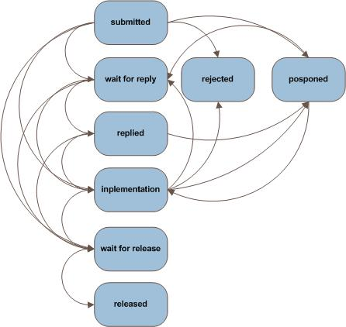
Figure 5: Sequence Diagram, of the submission statuses.

Screenshots
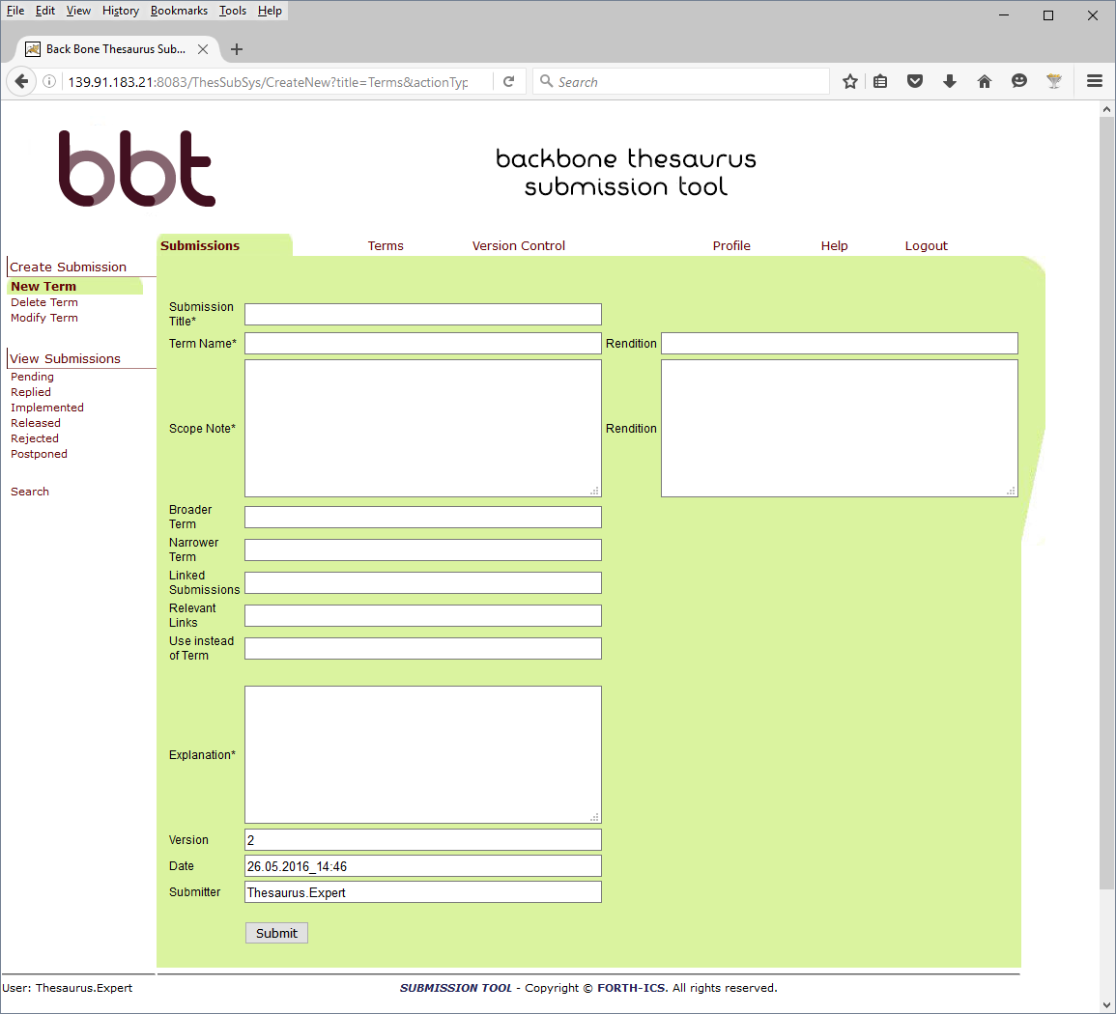
Figure 6: Make a submission to create a New BBT Concept (New Term)
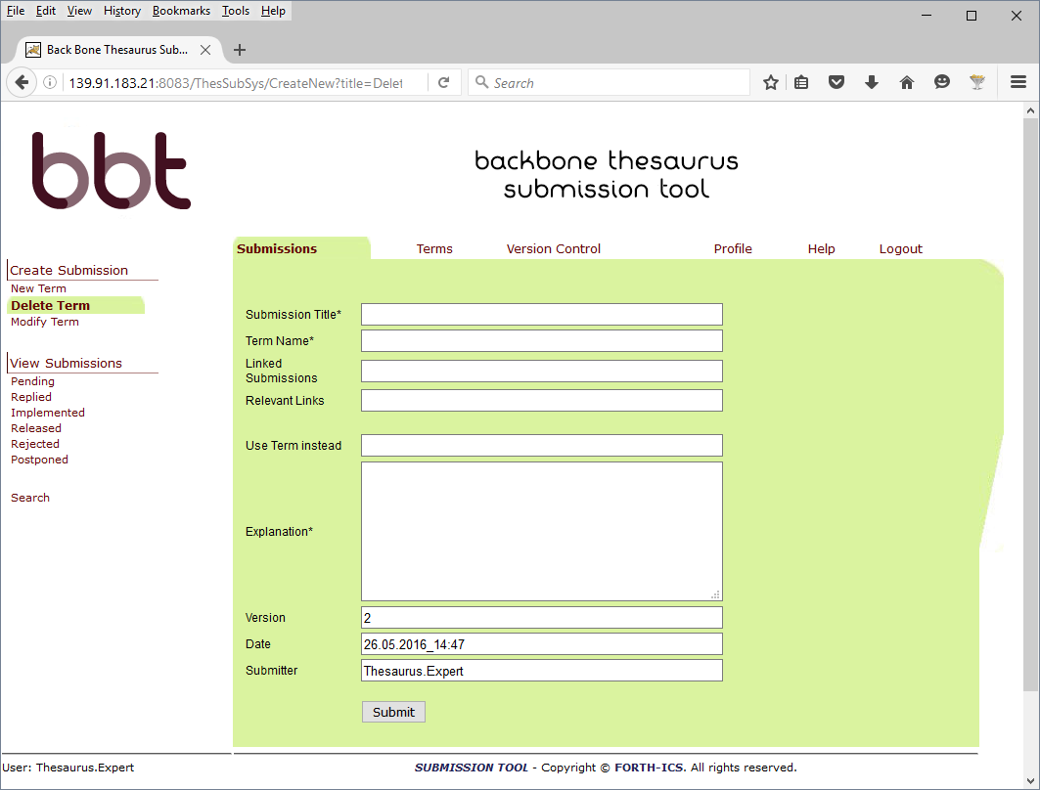
Figure 7: Make a submission to delete a BBT Concept (Delete Term)

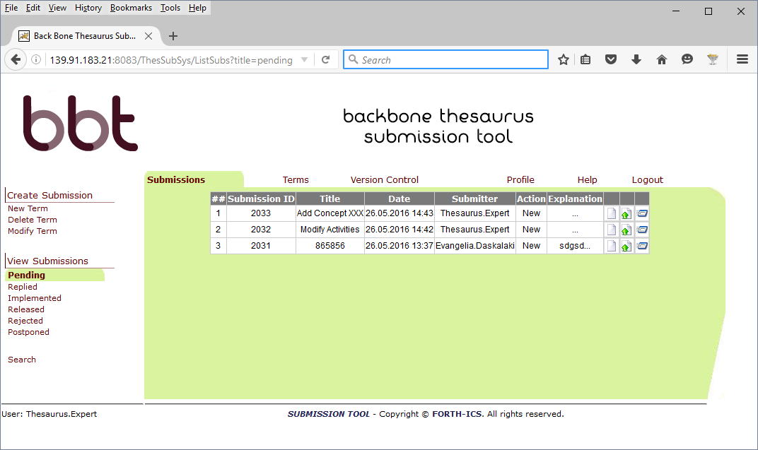
Figure 8: List all pending submissions

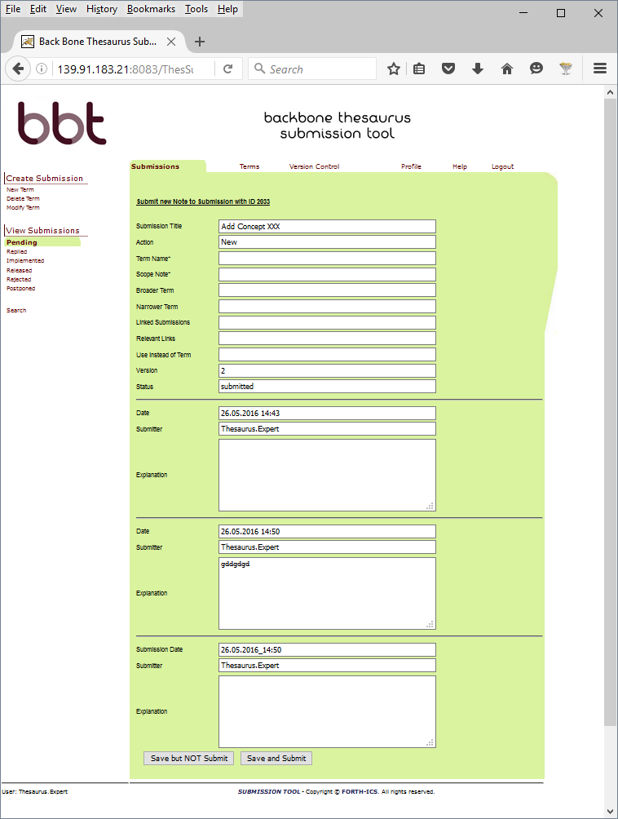Figure 9: View a submission history

Implementation details

System Architecture
The system is developed on a 3-tier architecture, which allows us to create a modular code that can be easily maintained and expanded.
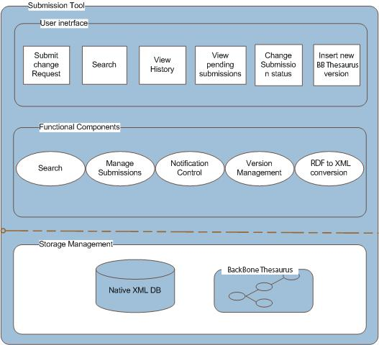
Figure 10: System Architecture
Storage management
The storage management module includes a XML Database where all the converted XML documents, the XML submission files as well as the configuration files for the users, the permissions, the Queries and all the versions of the BBT are stored. Each version of the BBT includes the thesaurus information in an RDF (SKOS) document. The system contains a copy of the current state of the thesaurus (the thesaurus, a SKOS RDF document, is digested into the system in form of XML file(s), containing the description of concepts and relations between concepts).
User interface
The user interface includes the interaction components that contributors, BBT-curators and domain experts use for the change requests, along with change-request reviewing and thesaurus versioning reviewing and the search. Notice that the actions provided to the users depend on the users’ role. This front-end of the system provides users with clear view of the operations available for the specific documentation stage. The system’s functionality is invoked with simple user actions, such as button selections etc.
Functional components
The functional components constitute the basic mechanism that incorporates all the system’s intelligence. It includes various functional modules such as the search mechanism for the submissions, search mechanism for the Concepts, the mechanism for adding a new submission, the permissions management component, the notification control mechanism, the version Management component, the RDF to XML conversion module, etc. These modules are invoked by user actions or through the interaction with other modules and react with the storage mechanism.

System Platform
Web Application Server and Web-browser
The Submission system is a web based on-line application, which is based on client-server architecture. As mentioned earlier, the system is developed using J2EE technology, on a 3-tier architecture, which allows us to create modular code that can be easily maintained and expanded. It is accessible to every user who owns a login account. The only prerequisites for using the tool are access to the World Wide Web (Internet) and a Web Browser (e.g. Internet Explorer, Mozilla Firefox, etc.).
Database
The system Database stores XML documents that have been produced from the conversion of the RDF (SKOS) document, the XML submission documents that include all the history of the concepts of the BBT, the requests for changes, as well as the stored Queries for the users, the configuration files for the user permissions etc.
We have chosen eXist Native XML DB, as our system database. The choice has been made based on the following criteria: documentation, reputation, encoding support, interface capability with other systems, as well as the cost (open source).
Operating system
The Submission system Application Server is developed and operated on a Windows Operating system, but we expect to run smoothly on any operating system since the underlying technologies are running on any operating system.

System Demonstrator
- Web Application http://139.91.183.21:8083/ThesSubSys
For login details please contact georgis@ics.forth.gr or bekiari@ics.forth.gr

Thesaurus federation viewer
Since the different thesauri of the proposed Thesaurus federation (BBT and local thesauri) are located (as their common concepts are only linked) and accessed by different systems (as each thesauri may provide its specific viewer) we should provide a thesaurus federation viewer that would enable to browse, navigate, visualize and use the different thesauri of the proposed Thesaurus federation. This viewer should be able to work with the different thesauri (them being either available online or cashed) providing a single interface.
(This document works as a design document, so we welcome any suggestions).

“A model for sustainable interoperable thesauri maintenance”, produced by Thesaurus Maintenance Working Group, VCC3, DARIAH EU, Version 1.1, January 2016, (http://83.212.168.219/DariahCrete/sites/default/files/dariah_bbt_v_1.1.pdf)
Notice that modification of a concept, may mean the change of its scope note, the change of its label, change of its relations to other concepts, etc. A complete list of all the possible changes of concepts should be defined later in this report.
If the list of the possible changes of concepts is not fully defined we welcome any suggestions to complete it.

