54th CIDOC CRM & 47th FRBR/LRMoo SIG Meeting,
13-16 September 2022

Faculty of Architecture, Sapienza University of Rome
(Piazza Borghese 9, Rome)

Participants
Achille Felicetti (PIN & UniFI, ITA); Agnese Galeffi (SBS- Sapienza, ITA); Alessandro Adamou (Bibliotheca Hertziana-Max Plank Institute for Art History, ITA); Anais Guillem (LRMH & CNRS-MAP, FRA); Athanasios Velios (UAL, GBR); Athina Kritsotaki (ICS-FORTH, GRC); Christian-Emil Ore (University of Oslo, NOR); Chryssoula Bekiari (ICS-FORTH, GRC); Denitsa Nenova (TAKIN.solutions, BGR); Donatella Fiorani (Sapienza University of Rome, ITA); Eleni Tsouloucha (ICS-FORTH, GRC); Elias Tzortzakakis (ICS-FORTH, GRC); Erin Canning (LINCS, CAN); Flavia Bruni (ICCU, ITA); Francesco Beretta (UMR 5190 LARHRA, FRA); George Bruseker (TAKIN.solutions, BGR); Gerald Hiebel (University of Innsbruck, AUT); Hallvard Indgjerd (Museum of Cultural History-University of Oslo, NOR); Igor Bajena (Hochschule Mainz, DEU & University of Bologna, ITA); Jörg Hörnschemeyer (Deutsches Historisches Institut in Rom, DEU); Juliane Hamisch (Germanisches Nationalmuseum Nurenberg, DEU); LIda Harami (ICS-FORTH, GRC); Maja Žumer (University of Ljubljana, SVN); Mark Fichtner (Germanisches Nationalmuseum Nurenberg, DEU); Marta Acierno (Sapienza University of Rome, ITA); Martin Doerr (ICS-FORTH, GRC); Mélanie Roche (BNF, FRA); Mercedes Menéndez (University of Oviedo, ESP); Muriel van Ruymbeke (C2DH, LUX & ULiege, BEL); Nils Geißler (CCeH-University of Cologne, DEU); Pat Riva (Concordia University, CAN); Pavlos Fafalios (ICS-FORTH, GRC); Philippe Michon (CHIN, CAN); Puyu Wang (University of Oxford, GBR); Robert Nasarek (Germanisches Nationalmuseum Nurenberg, DEU); Sanaz Emami (UT, IRN); Stephen Stead (Paverprime Ltd., GBR); Trond Aalberg (OsloMet, NOR); Vincent Alamercery (UMR 5190 LARHRA, FRA); Wolfgang Schmidle (DAI, DEU)

Table of Contents
54th CIDOC CRM & 47th FRBR/LRMoo SIG Meeting, 13-16 September 2022 1
Faculty of Architecture, Sapienza University of Rome (Piazza Borghese 9, Rome) 1
Participants 1
Tuesday 13 September 2022 3
Issue 600: Class and property labels are not definitions 3
Issue 599: Editorial Statuses of the CRMbase & family models 3
Issue 354: Management of Issues and workflow 4
Issue 603: Contextualize issues in a more informative way 4
Issue 596: Supplementary documentation 4
Issue 601: publish research questions on the website 5
Issue 606: Adjust scope notes of P7 & P161 6
Issue 605: Improve voting process 6
Issue 597: define irreflexivity and asymmetry 7
Wednesday 14 September 2022 7
Issue 595: Update synchronization btw CRMbase and CRMsci 7
Issue 569: descriptive text for CRMsci diagrams 7
Issue 388: Reference to the measurements of position of things 7
[NEW ISSUE]: scope notes for the properties of Position Measurement 8
[NEW ISSUE]: Diagrams in the Introduction section of CRMsci 8
Issue 583: How to assign dimensions to relative positions/ to distances in space-time and other relations between observable entities 8
Issue 536: Properties for assigning dimensions to places and temporal entities 8
Issue 598: How to specify possible observable situations in the future 9
Issue 481: scope notes for socP21 and socP22 9
Issue 482: CIDOC CRM interfacing risk assessment in conservation 9
Issue 360: LRMoo 14
[NEW ISSUE]: INVERSE SHORTCUTS 16
Issue 572: R34 has validity period 16
Issue 594: semantically replacing Recording Event and Externalization Event 17
Issue 590: Review of properties –request for comments 17
Thursday 15 September 2022 17
Issue 606: Adjust scope notes of P7 & P161 17
[NEW ISSUE]: the formal representation of FOL axioms in CRM 17
[NEW ISSUE]: New examples for P161 has spatial projection 18
CRMtex Issues (549, 546, 545) 19
Issue 510: Belief Adoption 22
SEMAFORA Project; Proposal for New CRM Classes and Properties to Serve Archaeological Field Survey 22
Typed and negative typed properties; Multiple individuals and negation in the CIDOC CRM 23
NEW ISSUE: Deprecate Typed Properties in CIDOC CRM? 23
NEW ISSUE: Interfacing the closed world assumption of NTPs with CRMinf 23
Issue 476: Pxxx represents entity of type 23
Issue 322: Reification of E13, S4 and I4 24
NEW ISSUE: Definition of I4 Proposition Set and what an instance of I2 Belief is about 24
Issue 534: Representing .1 properties of full paths in shortcut properties 24
Issue 599 (reprise) 25
Issue 547: CRMdig update 26
Planning the meetings for 2023 26
Friday 16 September 2022 26
Architectural conservation and digital humanities ontologies, heritage and risk; A meeting to discuss the application of CIDOC CRM. 26
Roundtable Discussion: Interoperability and Ontologies 27
Appendix 28
List of abbreviated names 28
Issue 595 28
Issue 360 29
Issue 388 38
Issue 481 39
Issue 606 40
CRMtex Issues (549, 546, 545) 43
Issue 510 49
Issue 534 51
Issue 599 59

Tuesday 13 September 2022

Issue 600: Class and property labels are not definitions
HW by EC, TV and MD -text intended for the introduction section of the CRM (end of Naming Conventions section). Details below:
Discussion:
The phrase “Nominal groups” applies to classes but not properties. Properties contain verbs, so by default they are not nominal groups.
The introduction explicitly mentions “Nominal Groups” (specifically for classes) and there was an effort to keep the labelling consistent.
Proposal: introduce the text provided, and start a new issue on rephrasing the “nominal groups” part.
Naming Conventions
- […]
- The names used to identify classes and properties are also referred to as ‘labels’. While the goal of a label is to approximate the meaning of the class or property in a few words, it is in general impossible to distil the nuance of the represented concept into a sentence fragment with the limited terms of one particular natural language. Relying on the label to infer the meaning of the class or property introduces significant potential for misunderstanding. Therefore, these labels should instead function as reminders of the corresponding scope notes only. As the labels cannot encapsulate the intension of classes and properties, no assumption about the meaning of a class or property should be made from its label alone
Inheritance and Transitivity
Decision: The text will be introduced in the CRM specification document.
Issue closed

Issue 599: Editorial Statuses of the CRMbase & family models
PF presented the HW prepared by FORTH (workflow for maintaining CRMbase and family models and updating the available statuses). The final version of the HW was discussed again on the last day. Suggestions made by the SIG were incorporated in the HW. The details of status definitions and column definitions can be found in the appendix.
Discussion points:
- Graphics used in each model have to be accessible through their respective version. This applies to CRMbase and all family models alike. They should be in an editable format. This has become an issue for the translation initiative too. To be discussed again in the context of issue 596.
- Official status needs to be elaborated on a bit. Best to distinguish btw an ISO correspondent version and one that is submitted to ISO for approval. Everyone in agreement with this proposal.
  - Labels to consider instead of a subsumptive one “Official”: Official (ISO equivalent) and Official (base for ISO submission).
Decision:
FORTH to implement changes proposed by the SIG (addition of a 4th status and rephrasing of the definitions for Official (base for ISO submission) and Official (ISO correspondence)) and come back on the last day of the meeting with a proposal for the SIG to vote on.

Issue 354: Management of Issues and workflow
Discussing the issue was postponed. The HW is ready, it can be reviewed and handled through an evote possibly.

Issue 603: Contextualize issues in a more informative way
Proposal by EC –3 points:
- Informative introductions to issues and sessions by the chairs of each session—in collaboration with one of the CIDOC CRM SIG chairs
- Gentle intro to CIDOC CRM SIG procedures prior to meetings, to ensure that newcomers are not at a loss
- Reminders to HW owners that they need to share WDs prior to the meetings through the mailing list
Discussion:
Ns: 1, 3 an editorial group issue.
No.2: SIG members running the sessions can inform the SIG concerning how the pre-meeting went. It was quite informative and EC & TV received positive comments.
Decision:
Proceed as suggested, i.e.,
- for (1) we need to rely on the commitment of the Editors to ensure that the meetings run smoothly.
HW: Erin Canning to consider ways to encourage participation and better contextualization of issues
- for (2) assign a slot at each SIG meeting to give feedback on how the newcomers intro went.
- for (3) reminders are sent anyway, we just need to increase them in numbers.

Issue 596: Supplementary documentation
ETs presented the HW by FORTH for the issue. FORTH identified 4 types of documents that need be made available through the CRM site, namely:
- Documents relevant for all models, irrespective of their version (new section on the site under Resources):
Resources\Guidelines and Templates\Templates
  - Template for family models doc. (issue 384)
  - Example templates doc. (Issue 493)
  - Scope-Note Writing Examples doc. (issue 494)
Resources\Guidelines and Templates\Assisting Translations
  - Translation order proposal doc. (issue 528)
  - Best Practices Guide doc. (issue 528)
  - Governance Guideline (draft sketch) doc. (issue 528)
- Documents relevant for editing one particular version of CRMbase & family models and influence subsequent releases thereof (new section on the site under Home)
Home\Editorial Suggestions
  - Small Edits Checklist -submission form
  - An anonymized and non-editable copy of Small Edits Checklist -response sheet
- Documents relevant only for a specific version of CRMbase (in the Encodings\Classes and Properties Declarations of CIDOC CRM of the relevant version).
Resources\Versions of the CIDOC-CRM\relevant version\column name: Encodings\Classes & Properties declarations (HTML page)
  - overview of .1 properties per CIDOC CRM version (table for v7.1.2)
  - overview of the properties of the CIDOC CRM the domain and range of which are the same class (doc for v7.1.2)
Resources\Versions of the CIDOC-CRM\relevant version\column name: Figures
- a .zip file containing of all the graphics used in the version at hand in an editable format
Resources\Versions of the CIDOC-CRM\relevant version\column name: Data Examples
- RDF (& TTL) examples for the Winkelmann graphs (HW by NC for Issue 471)
- A comprehensive data example for the CRM from the museum Benaki with rich comments about form and contents (from the Old site) <they need be checked first>
- Documents conveying information on implementations of the CRMbase & family models in projects etc. –to be updated in a yearly basis
Community\Activity Documentation
  - Community Activity Documentation spreadsheet (doc)
  - Google form that generates spreadsheet
Decision: FORTH to implement the above.
Issue closed

Issue 601: publish research questions on the website
ETs presented the proposal re. where the documents showcasing methodological principles motivating particular modelling decisions should appear on the site. The proposal was that the documents be accessed on The Model\Use & Learn\Methodology\Ontology Engineering Methodology (in underscore, the new link on the website). As the identified documents fall under different categories (based on formal criteria), they will be classified as Resources\References, Resources\Technical Papers and Resources\Publications, respectively and they will also appear as links in the new subsite under Methodology.
Discussion points:
- Some explanatory text is needed as an introduction to the “Ontology Engineering Methodology” subsite. HW has to be assigned.
- Alternative places to consider for the new link to appear under: The Model\User Guidance\Ontology Engineering Methodology (new link in underscore).
- The documents should be made prominent on the site.
NO Decision. FORTH to revise the proposal.

Issue 606: Adjust scope notes of P7 & P161
CEO went through the HW he and MD drafted (reformulation of scope notes for P7, P161 and the FOL axioms that specify instances of said properties).
Part of the proposed reformulation of the scope notes concerns rendering the FOL expressions in prose.
Discussion points:
- The FOL formulas contain free variables, the semantics of which is not very clear (should be read as an implicit “for all”). HW for CEO to reformulate the axioms defining a place by the object that provides a reference space to it.
- P157 has been used for data mappings concerning the collapsed arch of the Reconstruction of Notre-Dame. She can provide examples of the mappings for the SIG to revise.
The SIG decided to postpone reaching a decision until Thursday, to give CEO, MD and TV to reconsider how to best express the axioms. See below.

Issue 605: Improve voting process
Proposal by EC to better document the outcome of votes (yes/no/abstain/ineligible) and to broaden membership to the SIG (extend it to persons rather than representatives of institutions). This way the outcomes of the vote will be better understood.
Discussion points:
- It is unreasonable to expect every SIG member to be in a position to have formulated an opinion for every open issue and every family model. In that sense, they needn’t be rushed to vote just for the sake of voting.
- Not everyone can be made a SIG member. There are requirements that the members of the SIG also be CIDOC members (at least by two thirds). Otherwise, the CIDOC CRM SIG would not be able to retain its status as a CIDOC Working Group.
- The number of negative votes needs to be registered somehow. Because if there are many negative votes, then there is no consensus.
- People that are not members of the SIG but are active in this community (take up HW, participate in meetings, use the CRM and help expand it) should be allowed to have an opinion re. how to resolve the issues discussed: i.e., when asked to vote, they should be able to vote
Decision:
Do not alter the current requirements for membership, however allow all participants present at a meeting to vote on issues they are interested in and/or involved in. Just as SIG members do, when opposing a proposal for a vote, they should offer some arguments backing their objections. In a similar vein, when they are voting for one among many alternatives, they should also back their opinion –like your average SIG member would do.
HW: EC (&TV) to come up with a plan to encourage participants give an opinion.

Issue 597: define irreflexivity and asymmetry
Start an e-vote for the definitions provided by CEO (HW).

Wednesday 14 September 2022

Issue 595: Update synchronization btw CRMbase and CRMsci
The proposal by TV is to update the definition of O1 diminished, in order to keep it in sync with its superproperty in a stable CRMbase version (v7.1.2 at the moment).
Proposal:
- Always mention which version of CRMbase a family model is consistent with.
- If one wants to produce a stable version of a family model (and provide an RDFS for it), they should create dependencies with a stable version of CRMbase. At present, the stable version for CRMbase is 7.1.2.
- Any updates on a family model that are dependent on modelling decisions on draft CRMbase models, should by default be considered Draft.
Decision:
- Alter the definition of O1 diminished to reflect the IsA relation it bears to P112 diminished as proposed. Details in the appendix.
- HW: Assign someone (haven’t found them yet) with running a systematic check of the CRMsci class/property hierarchy and see if anything else needs changing.

Issue 569: descriptive text for CRMsci diagrams
TV informed the SIG that the issue has closed, on the grounds that the available graphics reflect the current state of the model.
Diagrams and descriptive texts for Position Measurement will not be implemented unless the modelling decisions they are dependent upon are reached (measurements of distances, etc). Once the SIG has agreed on how to implement them, a new issue will start on the diagrams for the introduction and the accompanying texts (for CRMsci v2.0 –which will be aligned with CRMbase v7.1.2).
Decision: Issue Closed; proceed as proposed.

Issue 388: Reference to the measurements of position of things
MD presented HW by himself and TV
- new proposal for a definition of Sxx1 Position Measurement isA S4 Observation and set of properties that use it (details in the appendix)
- diagram showing the modelling constructs that Position Measurement forms part of.
- use case that illustrates instance of the modelling construct (how to deal with measuring from known positions –especially relevant for historical documents)
Discussion points:
- Difference btw Oxx2 has validity timespan and the inherited properties relating activities to their timespan: a condition (like in S19 Encounter Event) that the validity timespan must be included in the timespan that the measurement was performed.
Decision:
- The new class has been voted in, no negative votes.
- Start a new issue to discuss the properties for Position Measurement.
- Start new issue for the diagrams (and text descriptions) in the introduction section.
Issue closed

[NEW ISSUE]: scope notes for the properties of Position Measurement
Stems from issue 388. The properties that need be properly defined are
- Sxx1 Position Measurement. Oxx1 determined position (was determined by): E94 Space Primitive
- Sxx1 Position Measurement. Oxx2 has validity time-span (is position validity for): E52 Time-Span
- Sxx1 Position Measurement. Oxx3 measured position (was located by): S15 Observable Entity
HW: MD, GH (& TV to revise). The definitions should feed into the issue for the diagrams & text descriptions of Position Measurement.

[NEW ISSUE]: Diagrams in the Introduction section of CRMsci
Stems from issue 388 and [NEW ISSUE] above:
HW: AK, TV to produce the diagrams and small text descriptions for Position Measurement & properties in the introduction section of CRMsci.

Issue 583: How to assign dimensions to relative positions/ to distances in space-time and other relations between observable entities
Proposal by MD to introduce two new classes in CRMsci:
- Sxx2 Relative Dimension (isA E54 Dimension), and corresponding property
  - Oxx6 is relative to: S15 Observable Entity (2:2,0:n) IsA O12i has dimension of (is dimension of), plus
- Sxx3 Angle (isA Relative Dimension), and corresponding property
  - Oxx7 has vertex: S15 Observable Entity, IsA Oxx6 is relative to
Discussion points:
- Similar situation in Linked Conservation Data project: the solution they went for was extremely elaborate and involved defining a reference system through CRMgeo and then approximating the locations of each object. This solution simpler, hence preferable.
- Defining proposed classes/properties logically precedes defining how auxiliary measurements are combined into a Position Measurement
Decision: Assign HW to draft scope notes for proposed classes and properties.
HW: MD, GH, MA, DF (& TV to review)

Issue 536: Properties for assigning dimensions to places and temporal entities
No HW ready, postpone until the next meeting. Send reminders to GH & DH.

Issue 598: How to specify possible observable situations in the future
No HW ready.
HW reassigned to a larger group: MD, TV, DF, MA, MvR, SdS, AA
Way to move forward: Organize a meeting among them and determine how Situations can be formulated from different fields.

Issue 481: scope notes for socP21 and socP22
The SIG discussed the scope note adjustments proposed for CRMact by TV. Details in the appendix.
Discussion points:
Packing too much information of a different kind in one and the same construct. Containment inferences are adequately captured with the proposed properties.
For places, containment is very basic, but other relations (overlap) should be explored too [f.i., tsunami waves covering an area, the place covered could only partially overlap with the place specified by the event template]
For timespans, one could resort to properties defined based on Allen operators. An event that matches a template for its specified timespan only needs to declare what portion of the specified timespan it matches (through P81/82 for instance).
The requirement for containment for specified timespans does not allow timespans extending beyond the foreseen timespan to be matched to them.
Proposal (to be reconsidered in the next SIG meeting)
For specified place: keep proposed reformulation by TV but change label to reflect “containment relation”, f.i., “specifies place within”. Introduce a second property for overlap relations. Make sure that CRMbase is not duplicated as an event template specification in the process.
Decision: TV to rework scope notes (HW)

Issue 482: CIDOC CRM interfacing risk assessment in conservation

Heritage at Risk. Managing data for conservation and prevention in architecture.
Presentation by Donatella Fiorani & Marta Acierno

CRM Conservation Overview of Model
Presentation by Thanasis Velios -Overall comment: the modelling is grounded on conservation data for architecture and the risk assessment models that DF & MA have been working on. It can be extended to other domains as well.
The constructs shown can be found below.

Vulnerability Assessment Slide:
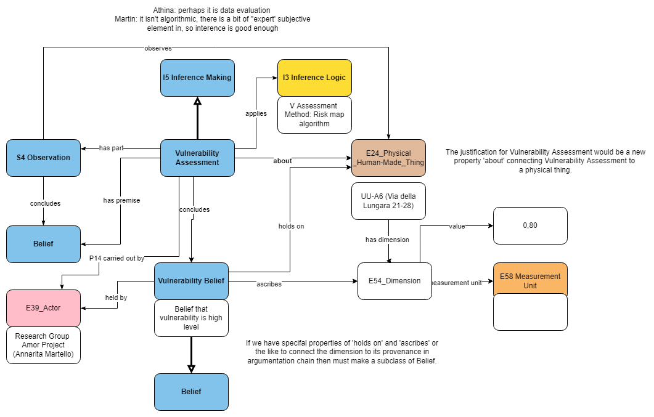
Figure 1: Vulnerability Assessment
- New classes:
  - Vulnerability Assessment (isA I5 Inference making)
  - Vulnerability Belief (isA I2 Belief)
- New properties: about [D: Vulnerability Assessment, R: E24 Human-Made Thing]
Discussion points:
Consider the possibility of specializing its superclass (make it IsA S6 Data Evaluation) or (better) make some of its subparts/phases IsA Data Evaluation.

Danger Assessment I, & II Slides:
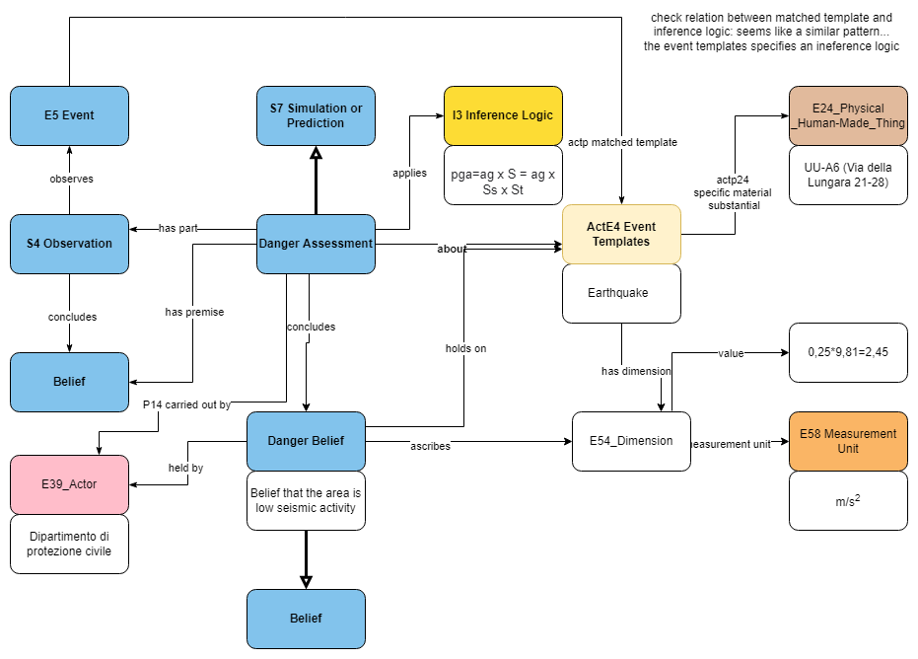
Figure 2: Danger Assessment I
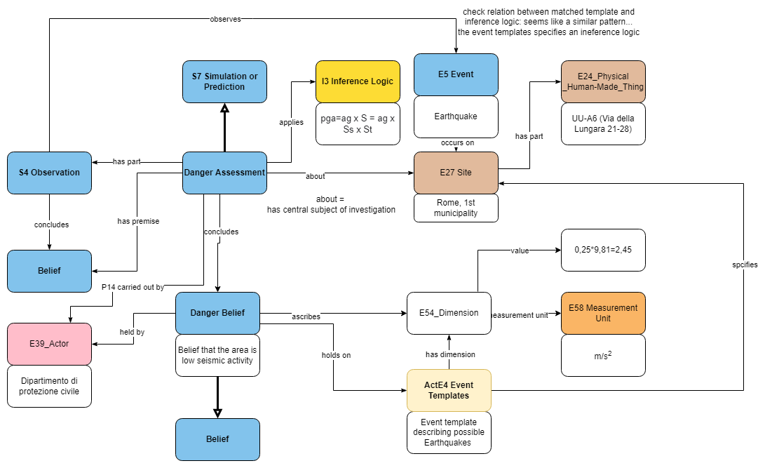
Figure 3: Danger Assessment II (alternative)
- New classes:
  - Danger Assessment (IsA S7 Simulation or Prediction)
  - Danger Belief (isA I2 Belief)
Discussion points:
The relationship btw a past event and the template it helps define is not self-evident.
The location of a building is what is being assessed. The connection to the area is very significant, but the 2nd slide sort of duplicates structures from CRMgeo with no apparent gain. To be reconsidered. Preference for option No.1.

Exposure Assessment I & II Slides
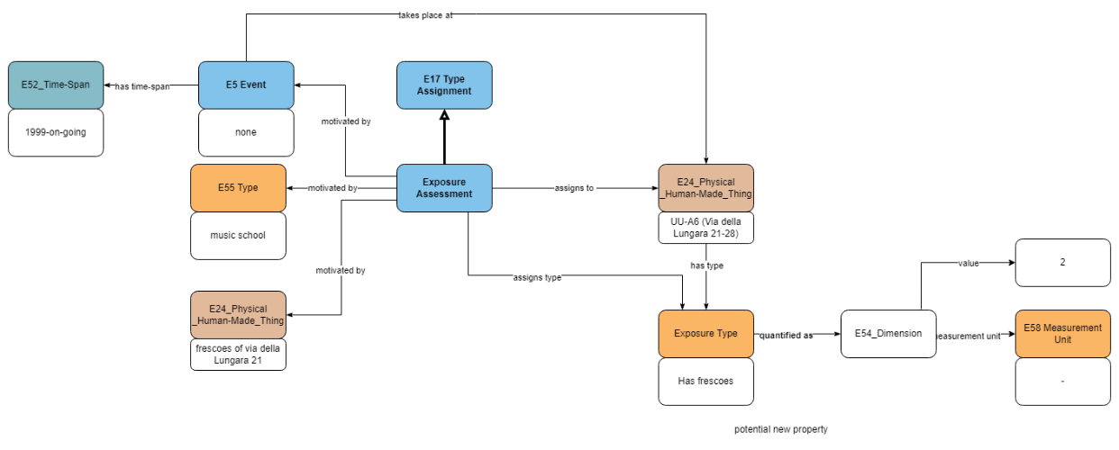
Figure 4: Exposure Assessment I
- New classes:
    - Exposure Assessment (IsA E17 Type Assignment I5 Inference making)
    - Exposure Type (IsA E55 Type)
- New properties: quantified as [D: Exposure Type, R: E54 Dimension]
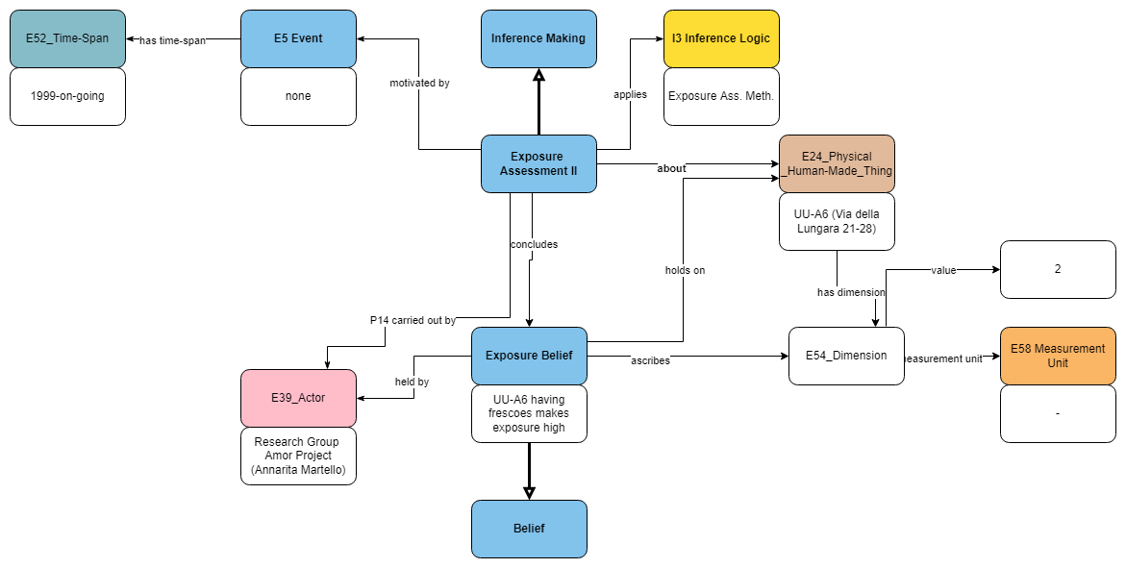
Figure 5: Exposure Assessment II (alternative)
- New classes:
  - Exposure Assessment (IsA S8 Categorical Hypothesis Building I5 Inference making)
  - Exposure Belief (isA I2 Belief)
- New properties: about [D: Exposure Assessment, R: E24 Human-Made Thing]
Discussion points: The superclass of Exposure Assessment: IsA E17 Type Assignment or S8 Categorical Hypothesis Making? If the latter, it can use the J2 concluded that to point to an Exposure Belief.
Preferably an I5/S5 Inference Making, given that its subclasses have not been completely defined yet.

Risk Calculation Slide:
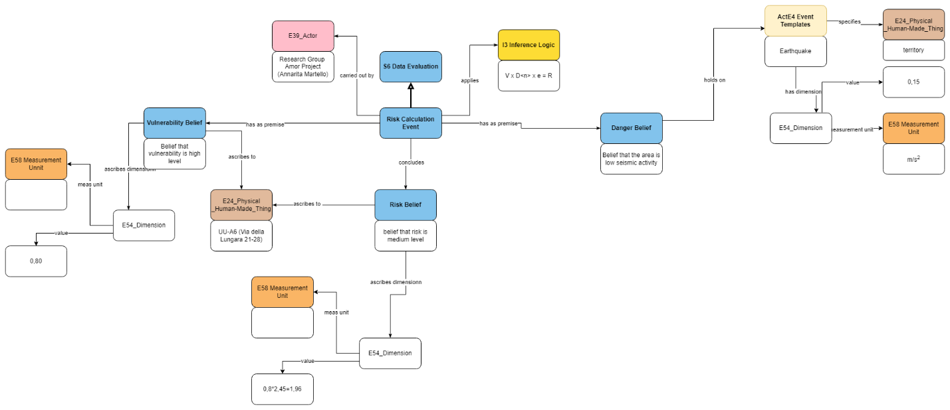
Figure 6: Risk Calculation Slide
- New classes:
- Risk Calculation Event (IsA S6 Data Evaluation)
- Risk Belief

Overall Discussion points:

Re. the E58 Measurement Units that do not exist:
The dimensions for vulnerability and risk are the output of mathematical calculations from either absolute numeric values or relative numeric values on an abstract scale (or both). In that sense, there is no evident measurement unit.
- See Slide Exposure Assessment I, path: Exposure Assessment. assigns type: Exposure Type {“has frescoes”}. quantified as: E54 Dimension. has value: E60 Number {“2”}. It’s like using a Likert scale to present qualitative description as a quantitative type. The range of possible values allows one to make calculations, but there is no objective measurement unit involved -just a relativization of possible values of whatever counts as the unit of analysis.
- The property “quantified as” allows some subtyping into ordinal types -like in CRMsci.
- Alternative: “quantified as” should be parallel to “assigned (type)” and not a property of the type.
- Where Dimensions are assigned some number, then the formulas deriving them need to be examined again to determine what the dimensions of the constituents of the formulas are and derive a measurement unit from them (see Vulnerability Assessment).

Standalone CRM extension or part of CRMact?
- Start with a narrow scope on Conservation of buildings and Risk.
- The kinds of risks described and vulnerabilities etc should be directly amenable to Risk Assessment for Industrial Planning, or Library Risk assessment.

Decision:
TV, MA, DF, GB things to reconsider:
- Since there is an immediate need for Rome to produce this model, then the group should carry on working on the specific model. Then we can see how this model fits in the overall CRMact universe.
- Property “quantified by” do not go through type but through an assessment activity to a type.
- Dimensions without measurement units: try to unpack what the units should be on the basis of the components making up the formulas used to derive the values for said dimensions.
- Make Exposure Assessment IsA I/S5 Inference Making.
- Produce scope notes for classes and structures that are better understood and provide real-life examples to put them to the test. Collaboration with Historic Environment Scotland.
- Draw contacts and project information from the Marie-Curie network for relevant lines of work.

Issue 360: LRMoo
PR walked the SIG through a series of issues stemming from the mapping of IFLA RLM to FRBR/LRMoo

Superclass of F3 Manifestation:
Background: In IFLA LRM LRM-E3 Expression and LRM-E4 Manifestation are disjoint. Declaring F3 as a subclass of F2 in LRMoo goes counter to this, and many run into issues with the relationship of F3 to F1.
Proposal:
- Keep F2 Expression and F3 Manifestation disjoint, like in LRM-ER (make them both direct subclasses of E73 Information Object) –F2 standing for content and F3 for container of the content.
- In a similar vein, modify the superclass relation of F30 Manifestation Creation (declare it a subclass of E65 Creation and E12 Production, instead of F28 Expression Creation)
Decision: Proceed as proposed. Details in the appendix.

New properties mapping to LRM-R20 and LRM-R29
Background: instead of mapping IFLA LRM properties to very high-level, underspecific properties, introduce semantically equivalent properties in the LRMoo.
Proposal: Introduce two properties (R77 accompanies or complements, and R78 has alternate) that exactly map to LRM-R20 accompanies or complements and LRM-R29 has alternate, respectively. Definitions in the appendix.
Discussion points:
- The point seems valid. These properties cannot be exactly mapped to anything existing in the CRM universe. In that sense, new properties have to be introduced to LRMoo.
- There is no requirement for CMR-family models’ properties to be declared subproperties of CRMbase (either directly or through inheritance). In that sense, it suffices that R77 and R88 are listed under their direct superproperties in LRMoo (insofar as they do have superproperties in LRMoo). The long paths given are commonsensical enough, but the proposed properties are much more specific.
- Using a long path from the IFLA LRM to LRMoo mapping as a superproperty, is it considered good practice? To be considered again.
- The concept of shortcut also falls short of this description (R78), because in the CRM universe, the long path -shortcut relation implicates that the shortcut is a consequence of the long path. Here it is not the case, the shortcuts are much more specific than the long paths –should be dubbed an “Inverse shortcut” instead. Ignore this for the time being, but it needs to be checked in LRMoo and other extensions.
Decision: Introduce the two properties into LRMoo.
Start a new issue to check inverse shortcuts in the CRM (base and family models). Insofar as we mention inverse shortcuts in the properties’ declarations, we need to define the concept -and check if it applies elsewhere too.

New property to map LRM-E2-A2 Representative Expression Attribute
Background: the mapping for LRM-E2-A2 Representative Expression Attributes does not quite provide the same semantics. LRMoo R73 expresses the concept of labelling an expression as representative, which is not the same.
Proposal to introduce a property that points directly from F1 Work to E55 Type: R79 has representative expression attribute (is representative expression attribute of), [D: F1, R:E55]–details in the appendix.
Discussion:
This construct relates to issue 556 (Content of minimal vocabularies restricting the CRM types) and the type hierarchies that we need to develop.
There are some kinds of expression closely related to any given work (they are dependent on its type). Their presence in the documentation of the work is not necessary however. In the absence of value for such an attribute, we do not fail to characterize the respective work as being of a certain type.
Reconsider the relation btw R79 and the path F1.R73:F2.P2:E55 (etc.). If it is a long path -shortcut relation. Reconsider if it needs a .1 property as well.
Decision: Admit property in LRMoo.

Relabelling class/properties to match IFLA LRM labels
Affects:
- F32 Carrier Production Event: change to F32 Item Production Event
- R5 has component (is component of): change to R5 has part (forms part of)
- R7 is materialization of (is materialized in): change to R7 exemplifies (is exemplified by)
- R33 has content: change to R33 has string
Discussion:
Re. R5: it should evoke the semantics of its superproperty (P148 has component). Also, two ways of splitting any information object: randomly selected fragments (rendered by a has part-like property) vs. meaningful, structural parts (rendered by a has component-like property). R5 explicitly refers to the latter case, and its label should evoke its semantics.
Decision:
Proceed with the relabeling as proposed, except for R5 has component (is component of), whose label will be retained

[NEW ISSUE]: INVERSE SHORTCUTS
Start a new issue to check inverse shortcuts in the CRM (base and family models). Insofar as we mention inverse shortcuts in the properties’ declarations, we need to define the concept -and check if it applies elsewhere too.
HW: unassigned

Issue 572: R34 has validity period
Propose to deprecate R34 has validity period (also F34 Controlled Vocabulary, its domain class). The notion of a validity period is so much broader than a skos:Concept and scheme. A scheme would be an F2 Expression that has a type, that was specified at one time.
Discussion:
R34 is too narrow, cannot be extended to other things besides a controlled vocabulary at this time. A broader conceptualization would allow to capture all the different things that come with validity periods (laws, rights, plans, observations, volatile digital objects, etc.).
Classification schemes are good examples of things that have a validity period (relates to versions etc.). The validity period does not have to be “the present”, but the validity period of the version in question.
The construct has a state-like quality to it, which seems to be clashing with the CRM-event centric approach.
Proposal:
- Deprecate F34 (use E32 Authority Document) and R34 (whose domain is F34) in LRMoo
- Keep the issue open, but separate from LRMoo (i.e., link it to CRMbase instead). Produce a more general property for validity periods in general.
- Could also be reconsidered in the scope of CRMdig & PARTHENOS harmonization (HW for GB and group working on issue 547) –define the validity period of authority documents seen as volatile resources (undergoing continual updates).
Decision:
F34 and R34 are deprecated in LRMoo. The issue will be kept open, but moved to CRMbase and CRMdig instead.

Issue 594: semantically replacing Recording Event and Externalization Event
Skipped, not enough time. Will be discussed at the next meeting.

Issue 590: Review of properties –request for comments
The issue is closed by decision of the LRMoo editors, on the grounds of not having received any remarks objecting the proposed quantifications of LRMoo properties within the specified time-range.

Thursday 15 September 2022

Issue 606: Adjust scope notes of P7 & P161
The SIG revisited the HW by CEO [FOL axioms and scope note reformulation for P7 & P161].
Decisions:
- The updated scope notes to be introduced to the version that will be submitted to ISO and v7.2.2 (the one edited by the 54th SIG meeting). For the details of the reformulations see [P7] and [P161], respectively.
- Update Table 4: CIDOC CRM Property Hierarchy accordingly
- Start a new issue regarding the FOL expression of axioms in the CRM specification document (see below).
- Start a new issue where to revise the examples provided by AG, concerning the restoration of the Cathedral Notre-Dame de Paris (see below).
Nb. WS objected to the FOL representation of the equality of instances in the axiom for P161
Issue closed

[NEW ISSUE]: the formal representation of FOL axioms in CRM
Upon discussing the redefinition of P7 took place at, the SIG decided to start a new issue concerning how to set up the FOL axioms found in the CRM specification document.
Things to be considered:
- allowing the use of as many free variables as possible in FOL axioms (understood as having an implicit universal reading) instead of adding unnecessary existential quantifiers;
  - whether free variables can they appear within the scope of another quantifier (f.i., the axiom for P7)
    - (∃u) [E4(x) ˄ E18(u) ˄ E53(y) ˄ P157(y,u) ˄ E53(z) ˄ P157(z,u) ˄ E53(v) ˄ P157(v,u) ˄ P7(x,y) ˄ P161(x,z) ˄ P89(z,v) ˄ P89(v,y) ] ⇒ P7(x,v)
could be rendered as:
    - E4(x) ˄ E53(y) ˄ E53(z) ˄ E53(v) ˄ ((∃u ∈ E18) [P157(y,u) ˄ P157(z,u) ˄ P157(v,u)]) ˄ P7(x,y) ˄ P161(x,z) ˄ P89(z,v) ˄ P89(v,y) ⇒ P7(x,v)
      - Free variables not in the scope of the existential quantifier
      - use of a set-theoretical notation in class declarations (does it help to better understand the axioms or is it considered overall cumbersome?)
- the concept of equality btw instances of classes that has been assumed for P161 is a newly introduced one. Before resorting to using it in an ad hoc manner, the SIG should consider what the implications of declaring equality among individual instances of classes are.
  - (∃u) [E92(x) ˄ E53(y) ˄ E53(z) ˄ E18(u) ˄ P157(y,u) ˄ P157(z,u) ˄ P161(x,y) ˄ P161(x,z) ] ⇒ (z = y)
- prior knowledge to be rewritten in the definition of axioms or is there any other way to represent background assumptions (should they be represented somehow)?
- Possibility of minimising FOL statements to the absolutely necessary inferences or keep whatever has been added in the FOL sections in the specification document?
The basis for the FOL definitions (except for the logical constants used throughout the CRM specification document though) should be:
Meghini, C. and Doerr, M. (2018). ‘A first-order logic expression of the CIDOC conceptual reference model’, International Journal of Metadata, Semantics and Ontologies, 13(2), pp. 131–149. doi: 10.1504/IJMSO.2018.098393.
HW: CEO, WS, MD to collaborate on that. Contact CM as well.

[NEW ISSUE]: New examples for P161 has spatial projection
Upon discussing the redefinition of P161 has spatial projection, AG provided some new examples for the property at hand. They all come from Notre-Dame reconstruction draft mapping, that she is currently working on.
Background for the examples:
The case study is the collapsed transverse arch of the N-D nave. The voussoirs collapsed and their trajectories were documented (ie. spatio-temporal annotation and identification of individual voussoirs in the remains) during the cleaning activities through photogrammetric scenes.
The examples-set can be found below:
- E22 [voussoir] - P196 defines - E92 Space Time Volume [trajectory of a voussoir];
- E92 Space Time Volume [trajectory of a voussoir] - P10 falls within - E92 Space Time Volume [transverse arch];
- E92 [trajectory of a voussoir] - P161 has spatial projection - E53 Place [location of fallen voussoir];
- E53 Place [center of gravity] - P89 falls within - E53 Place [location of fallen voussoir];
- E53 [center of gravity]- P172 - geo:wktLiteral
This property allows linking the data about the spatio-temporal annotation of voussoirs space time volumes and inferring a reconstruction hypothesis in regards to the fall location, inferred from the voussoirs’ tracking (appearance, disappearance, and extraction from the rubbles).
Decision: MD, CEO, AG to go through the examples and propose to incorporate them in the definition of P161 by the next SIG meeting.
HW: MD, CEO, AG

CRMtex Issues (549, 546, 545)
AF walked the SIG through the proposal to
- redraft TX5 Reading,
- introduce new properties for TX5 Text Recognition: TXP10 deciphered text, TXPxx1 deciphered via the representation, TXPxx2 used copy or representation of, TXPxx3 recorded transcript
- introduce new class TX6 Transliteration
- introduce new class TX8 Grapheme
- introduce new class TXxx1 Grapheme Occurrence
- introduce new class TXxx2 Grapheme Sequence
- introduce new class TXxx3 Script
- redefine TXxxx Reading
Points raised:
- overall emphasis on digital representations needs explaining: Digital renditions of a particular object have different identity conditions wrt. the original object or physical representations thereof.
- TX8 Grapheme a case of E90 Symbolic Object instead of E55 Type? Why make the abstract symbol a specialization of E55 Type and not of E90 Symbolic Object (and assign it a type)?
  - Characters correspond to universals wrt. the Script/Writing System they are part of. Characters used in an inscription are particular instances of that type.
  - Character Occurrences are specialisations of E90 Symbolic Object, and the type they are assigned is TX8 Grapheme.
  - Graphemes are defined in the context of a Writing System. Even for alphabetical writing systems that assume a more or less phonetic orthography, graphemes do not necessarily stand in a one-to-one correspondence with the phonemes they represent.
- The possibility of making TXxxx Reading IsA TX5 Text Recognition and IsA Ixx Meaning Comprehension
- Cross-referencing a model with not only CRMbase but other family models too, means that creating a stable version in that particular model is dependent on using stable versions of the relevant family models
The newly introduced classes form part of the following modelling constructs:
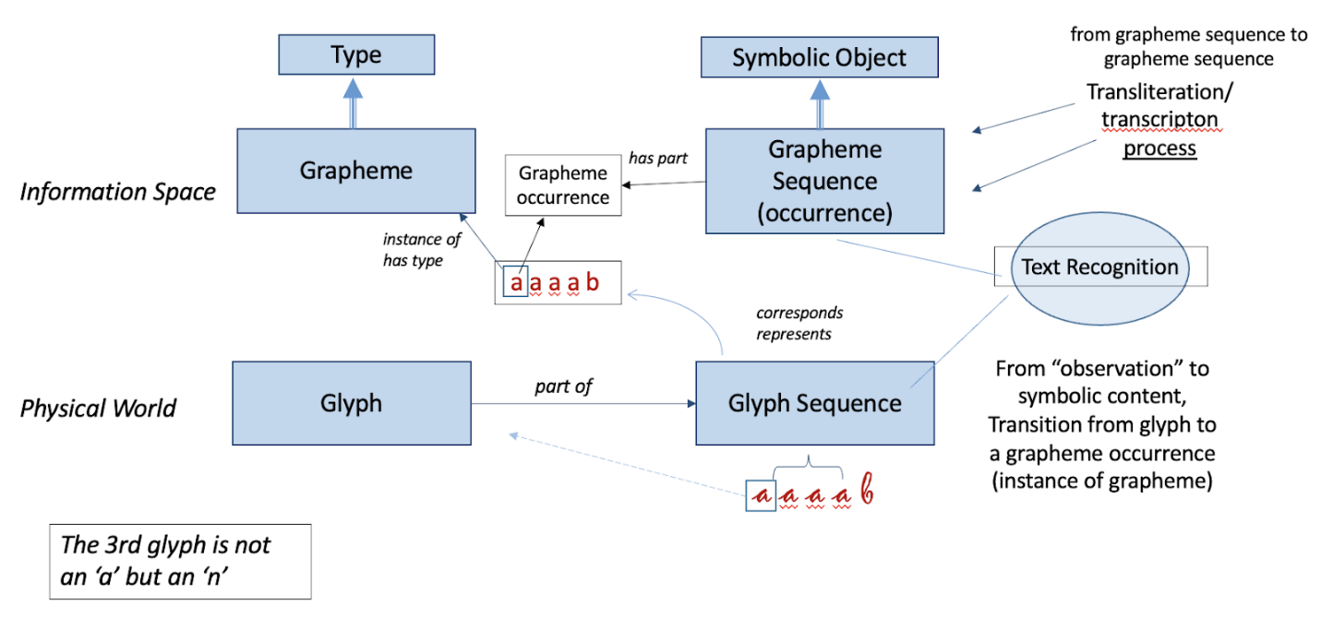
Figure 7: Text Recognition, Glyph Sequences recognition and Grapheme association
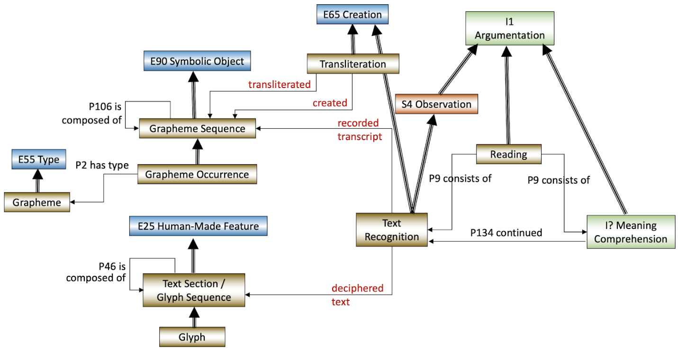
Figure 8: Text Recognition, deciphering and recording transcripts, and the new Reading conceptualisation
Decision: The proposal was overall accepted. Some minor editing also took place. The scope notes (redrafted and new ones) can be found at the Appendix.
HW: AF & FM to provide examples for the classes and properties that lack them (TXPxx2 used copy or representation of, TXPxx3 recorded transcript, TXxx2 Grapheme Sequence). Assign numbers to the newly introduced classes and properties.
Decision: When the properties for Script and Reading have been admitted into the model, produce a stable version of CRMtex. That version will need to be harmonised with the newest stable/official version of CIDOC CRM. We do not to harmonise compatible models with every newer stable version, but every now and then (in a period of a few years) to carry on with that.

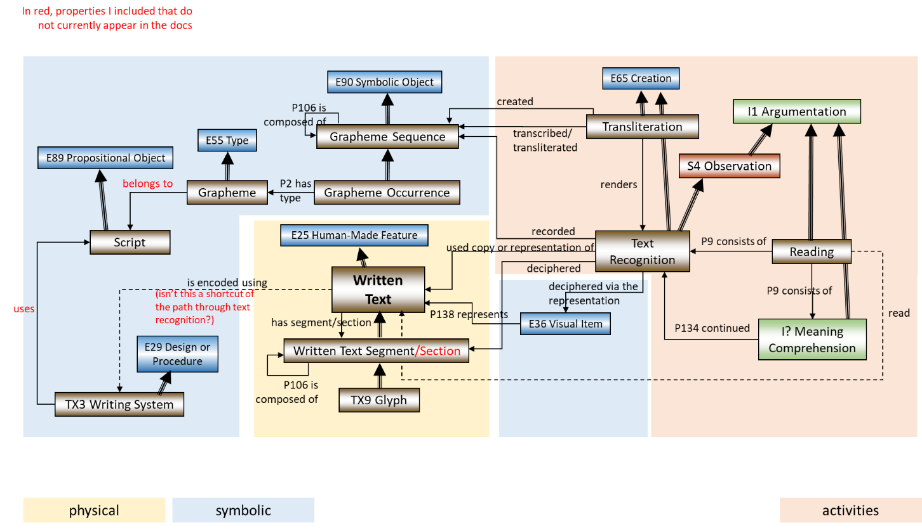
Figure 9: Overall modelling proposal (properties connecting classes)
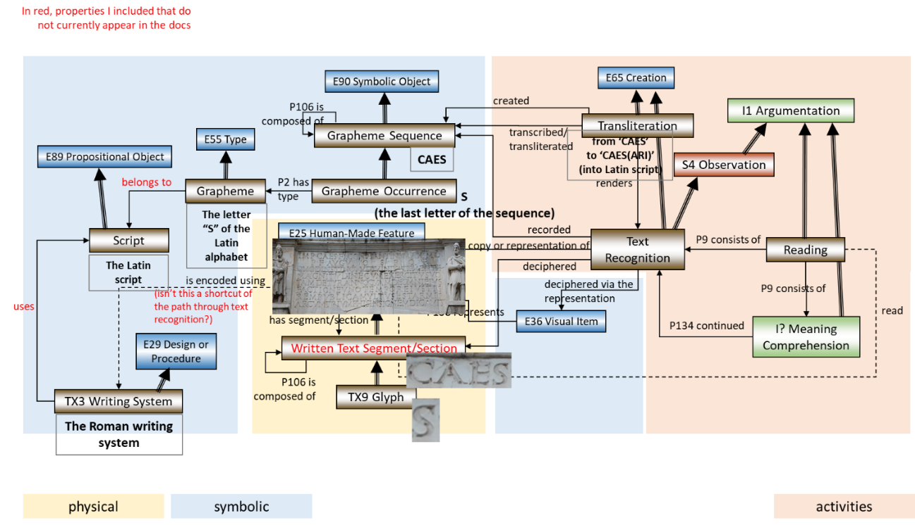
Figure 10: Example for overall modelling proposal

Issue 510: Belief Adoption
The SIG reviewed the model for I7 Belief Adoption (presentation by MD) and the reformulation of the scope note proposed I7.
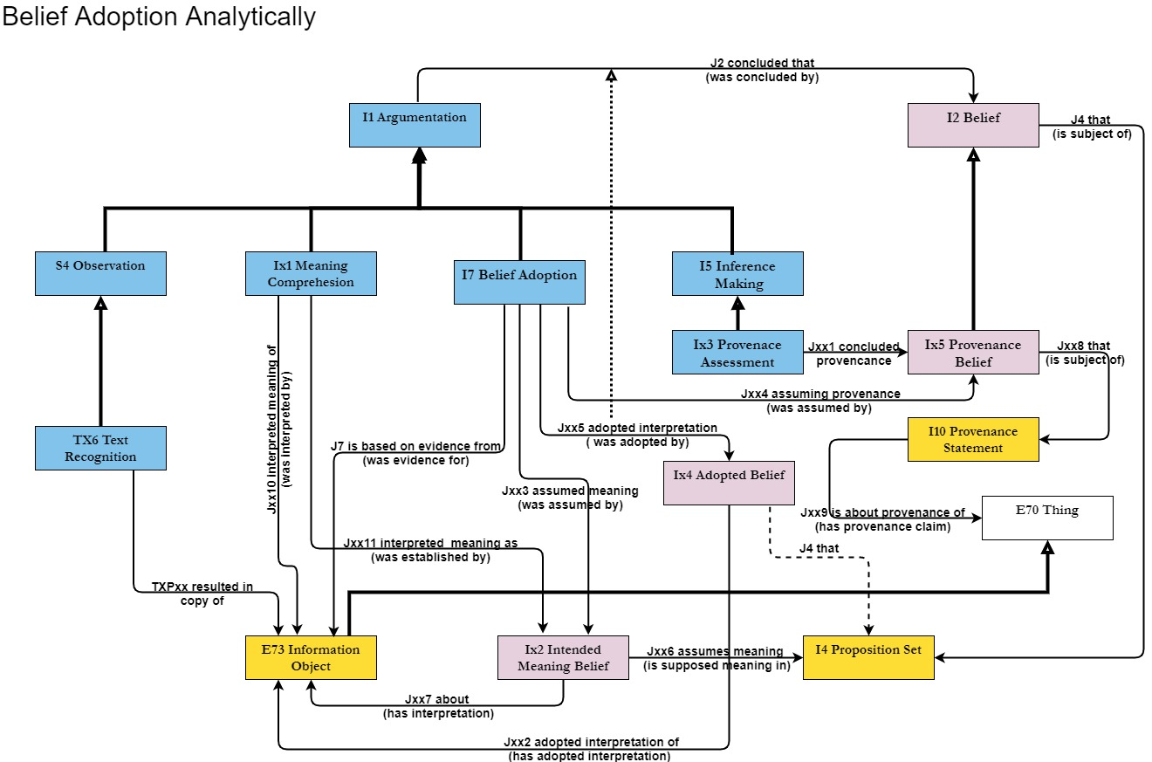
Decisions:
- The reformulated scope note was admitted into the CRMinf. Details in the Appendix.
- The example needs to be reformulated, it fails to attribute the Adopted Belief itself.
- Discuss and decide about the properties listed under I7 in the next SIG meeting.
HW: MD & PF to provide the scope notes for the properties in time for the next meeting.

SEMAFORA Project; Proposal for New CRM Classes and Properties to Serve Archaeological Field Survey

Denitsa Nenova, George Bruseker, Martijn van Leusen, Tymon de Haas, Sjoerd Siebinga
Link to presentation document here.
Discussion points: Interesting constructs to be integrated with CRMarchaeo. It would be a step towards providing a model to integrate all kinds of archaeological finds. A model for illicit trading would still be pending.
GH had proposed a model for Archaeological Field Survey in the past.
HW: SIG members assigned to work in the integration of this model with CRMarchaeo: AF, GH, CEO to collaborate with the SEMAFORA Project group. Discuss it in the next SIG meeting.

Typed and negative typed properties; Multiple individuals and negation in the CIDOC CRM

Thanasis Velios, Carlo Meghini, Martin Doerr, Stephen Stead
Link to presentation document here.
Link to published paper here. Link to test implementation of TPs & NTPs on GitHub here.

NEW ISSUE: Deprecate Typed Properties in CIDOC CRM?
Proposal: review the CRMbase –scout for existing TPs and deprecate them. The issue stems from the presentation of TV on (N)TPs. It also bears a strong relation to Issue 476.
Discussion points:
- Systematic deprecation of TPs will require some consideration: most of them are used frequently. Should also consider the possibility of treating inverse properties as TPs.
- Existing CRM properties can be treated with a same as statement as the TPs? TPs do not anything in terms of the semantics of the CRM. It is not an extension so that’s not the way to go about it.
- Closed world assumption entails that the domain instance has been completely observed. Interesting to connect how this type of statement relates to CRMinf. NEW ISSUE.
- The construct is useful for CRMarcheao (finding or not finding bones in a grave that one has dug up). The aim is that this technical solution can become an extension. It contains around 60 TPs and some of them are derived negative properties (to the extent that it makes sense semantically to implement each NTP).
- The semantics of NTPs needs to be addressed. Is it the case that something is not the case NOW or that it has never been the case? F.i., is it the case that there exist no remnants of a book-marker at the time of the examination/conservation or was there never a book-marker in a particular book? In general, if there is evidence that something had been there at a prior stage, then it would be classified as having existed. Also, something to be determined. HW to TV & MD to examine the properties for temporal ambiguities.
HW: TV to assess whether inverse shortcut properties can express TPs and discuss the temporal characteristics of (N)TPs.

NEW ISSUE: Interfacing the closed world assumption of NTPs with CRMinf
Expressing the idea that object x has been completely observed and it lacks feature z forces a closed-world assumption.

Issue 476: Pxxx represents entity of type
Based on the model for (N)TPs that TV presented, he proposes to deprecate P199 represents entity of type (it can be found in the CIDOC CRM v7.2.x branch), on the grounds that the information it conveys can be expressed through the (N)TPs model.
Proposal: Discuss deprecating the P199 (according to the proposal by TV) during the December meeting. The issue is left open until the SIG decides what to do P199.
HW: TV and RS to discuss how it fits into the TPs & NTPs model.

Issue 322: Reification of E13, S4 and I4
Open-ended discussion.
MD gave an overview of the issue; the idea is that an Attribute Assignment essentially talks about a single property instance, which forms a parallel to pointing to a named graph that contains one property instance. I1 Argumentation which results in an instance of I2 Belief cannot be a subclass of E13. There is also a problem with S4 Observation if the reification construct deals with more than one property simultaneously (what is now referred to as Situation).
CEO maintains that the CRM set of properties that are equivalent to a named graph can be represented as a set of propositions and the connection between them in FOL. One can always name that and say that the predicate “X” stands for a proposition, in CRM an instance of E89. On the other hand, the scope note of I4 Proposition Set explicitly refers to binary propositions and formal ontology concepts, which seems too restrictive. Logical constructs does not specify the order or mode of the logical system the statements are expressed in. This could yield propositions that are incompatible with the CRM. The scope note needs redrafting.
The idea is that CRMinf can be connected to CRM compatible knowledge base through such statements. As CRMinf stands now, it seems that many things that we regard as premises and conclusions won’t be formulated in properties that have been defined in a formal ontology. In general, the scope of CRMinf should be broader than what can now be expressed. The reference to name graphs should explicitly only leave room for named graphs that contain 1+ property instances alone (rather than instances of properties and classes or just the one property instance permitted by E13).
If there are any formalizations in FOL that can be used to declare the E13 reification of a single property as a specific case of a named graph, it would be interesting to look at it.
Proposal: close the issue, start a new one, where to redraft the scope note of I4 Proposition Set based on the comments above. “Definition of I4 Proposition Set and what an instance of I2 Belief is about”.
Everyone in agreement. Issue closed.

NEW ISSUE: Definition of I4 Proposition Set and what an instance of I2 Belief is about
HW: CEO & MD to formulate the new issue.

Issue 534: Representing .1 properties of full paths in shortcut properties
CEO gave an outline of the issue, and presented his HW (see appendix for details).
Premises:
- subproperties inherit the .1-properties from their superproperties.
- .1 properties do not stand in an IsA relation with the .1 version of the properties that are superproperties of their .1-less version by default. Instead decide on a case-by-case basis.
Proposal:
The relation of a short path with a .1 property to a long path containing a .1 property is not predetermined (compare (a) P62.1 and P138.1 to (b) P107.1 and P144.1, respectively).
  - If the corresponding .1 properties’ semantics appear unrelated, then restrictions need to be added to the shortcut property definition (a). Namely, if the long path has instantiated a .1 property, then the short path shouldn’t. The type on property in the long path implies any type, not the type of the property in the short path.
  - If the corresponding .1 properties’ semantics are unrelated, then an extra FOL axiom has to be added (b).
Decision:
Postpone reaching a decision. In the meantime, HW to CEO (and WS because he knows his FOLs) to check data instantiating .1 properties both in the long and the short path, in order to verify that the type restrictions are as proposed.

Issue 599 (reprise)

ISO Submission process
EC informed the SIG about the process of ISO submission (including the release number of the document that will ultimately be submitted to ISO): the first round of the document has been submitted to ISO for initial formatting and review. Minor corrections (editorial things) are still being performed on the document but the bulk of the work is now completed. The version they have been working on is 7.1.2, which is the version that forms the foundation of the ISO version.
EC & PM advise against v.7.2.1 (or any subsequent version of the 7.2.x branch) mirroring the ISO, as there is new content in there (P199). They also propose that the SIG stop editing the 7.1.x branch, that they take over this version and inform the SIG of any minor changes implemented during the ISO revision process. If the SIG spots some errors too, they should let EC & PM know about it, so that it can be edited in the version that will be submitted to ISO (v7.1.3). CIDOC CRM v7.1.3 will be the “true” foundation for ISO.
The SIG should carry on working on the 7.2.x branch. Any updates on the 7.1.x branch will not be shared through the site until the harmonization btw the ISO version and the community version begins.

Maintaining CRMbase versions
PF presented the updated statuses for CRMbase versions, their definitions and their correspondence to the existing (or upcoming) versions of the CRM. The proposal, found in the appendix, will substitute the existing definitions in the introductory text that appears under “Versions of the CIDOC CRM”. The version that is the result of editing the CRMbase during the 54th SIG meeting, will be v7.2.2.
Discussion:
Prior to assigning the status “Stable” to any newer version, a check for errors/cycles etc. should be performed (task for FORTH). If there are problems, the version should be labelled “Draft” instead -the editors should be informed of that.
Serialisations should only be provided for Stable versions (i.e., Official versions too).
Overall proposal: carry on as stated above, namely:
- CIDOC CRM v.7.1.x stops being edited by the community and passes over exclusively to the ISO group (EC, PM). No updates on this branch appear on the site from now on.
- The SIG continues editing the 7.2.x branch. Any updates (editorial/stylistic) that occur in this version are to inform the version submitted to ISO too.
- Once it has been submitted for ISO approval, version 7.1.3 will become relevant for the harmonization with the version maintained by the SIG.
- The definitions and correspondence to CIDOC releases proposed by PF will substitute the statues description under Resources in the CIDOC CRM site.
Decision: proposal accepted unanimously.

Maintaining versions of CRM family models
PF then presented the workflow for maintaining CRM family models and the definitions of the columns used to describe each version of a CRM family model. The available statuses of CRM family models form a proper subset of the models assumed for CRMbase.
Details of statuses and column definitions in the appendix.
Decision: proposal accepted unanimously.
Issue closed

Issue 547: CRMdig update
HW by GB. Link to presentation here.
SIG members back the proposal by GB. SdS wants to collaborate (to test with examples from work he’s currently undertaking with a group in San Francisco), MD and TV have volunteered to work on the harmonisation of CRMdig and PEM.

Planning the meetings for 2023
SIG members find it challenging to obtain travel funding for in person meetings, whereas at the same time, online and even hybrid meetings pose different kinds of challenges. The decision was to have 2 in person meetings. Online participation will also be available, but the necessary technological means for a seamless meeting should be provided. With that in mind, FORTH volunteered to host both meetings. The conference room at FORTH is fully equipped.
The meetings for 2023 will take place in May (9-12 May 2023) and September (26-29 September 2023), at FORTH.
Nb. At the time of the meeting, the SIG was unaware that all conference rooms are booked for the autumn meeting. The meeting has been rescheduled for the first week of October (3-6 October 2023) by the CRM Editors’ choice.

Friday 16 September 2022

Architectural conservation and digital humanities ontologies, heritage and risk; A meeting to discuss the application of CIDOC CRM.
CRM Family of Models; Representing Knowledge about the Past (Martin Doerr)
Sharing Knowledge about out pasts; A practical look on the application and future potentialities of semantic data (George Bruseker)

Roundtable Discussion: Interoperability and Ontologies
George Bruseker (Takin.solutions), Stefano Della Torre (Politecnico di Milano), Martin Doerr (ICS-FORTH), Donatella Fiorani (Sapienza Università di Roma), Stefano Francesco Musso (Università di Genova), Marco Pretelli (Alma Mater Studiorum - Università di Bologna), Athanasios Velios (University of the Arths, London)
Chair: Marta Acierno (Sapienza Università di Roma).

Appendix

List of abbreviated names

AA: Alessandro Adamou
AF: Achille Felicetti
AG: Anais Guillem
AK: Athina Kritsotaki
CEO: Christian-Emil Ore
DH: Daria Hookk
DF: Donatella Fiorani
EC: Erin Canning
ETs: Eleni Tsouloucha
FM: Francesca Murano
GB: George Bruseker
GH: Gerald Hiebel
MA: Marta Acierno
MD: Martin Doerr
MR: Melanie Roche
MvR: Muriel van Ruymbeke
MZ: Maja Zummer
PF: Pavlos Fafalios
PR: Pat Riva
RS: Rob Sanderson
SdS: Stephen Stead
TA: Trond Aalberg
TV: Thanasis Velios
WS: Wolfgang Schmidle

Issue 595

O1 diminished (was diminished by) redefinition

New definition
O1 diminished (was diminished by)
Domain: S1 Matter Removal
Range: S10 Material Substantial
Superproperty of: E80 Part Removal: P112 diminished (was diminished by): E18 Physical Thing
Quantification: many to many, necessary (1,n:0,n)

Scope note: This property associates an instance of S1 Matter Removal with the instance of S10 Material Substantial that this activity diminished.
Although an instance of S1 Matter Removal activity normally concerns only one item of S10 Material Substantial, it is possible to imagine circumstances under which more than one item might be diminished by a single Matter Removal activity.
An instance S1 Matter Removal activity requires to diminish at least one item of S10 Material Substantial. This may be realized by any of the subproperties of O1 diminished. Therefore the instantiation of a particular subproperty of O1 diminished is not necessary.
Examples:
The removal of the fill from the interior of the “tomb of Lagadas” at Derveni Thessaloniki by the excavators in 1995 (S1) diminished the width of the cross-section of the burial chamber and the fill of the façade. (S10).) (Papasotiriou, A., Athanasiou, F., Malama, V., Miza, M., Sarantidou, M, 2010).
In First Order Logic:
O1(x,y) ⊃ S1(x)
O1(x,y) ⊃ S10(y)

Old definition
O1 diminished (was diminished by)
Domain: S1 Matter Removal
Range: S10 Material Substantial
Superproperty of: E80 Part Removal: P112 diminished (was diminished by): E24 Physical Human-Made Thing
Quantification: many to many, necessary (1,n:0,n)

Scope note: This property associates an instance of S1 Matter Removal with the instance of S10 Material Substantial that this activity diminished.
Although an instance of S1 Matter Removal activity normally concerns only one item of S10 Material Substantial, it is possible to imagine circumstances under which more than one item might be diminished by a single Matter Removal activity.
An instance S1 Matter Removal activity requires to diminish at least one item of S10 Material Substantial. This may be realized by any of the subproperties of O1 diminished. Therefore the instantiation of a particular subproperty of O1 diminished is not necessary.
Examples:
The removal of the fill from the interior of the “tomb of Lagadas” at Derveni Thessaloniki by the excavators in 1995 (S1) diminished the width of the cross-section of the burial chamber and the fill of the façade. (S10).) (Papasotiriou, A., Athanasiou, F., Malama, V., Miza, M., Sarantidou, M, 2010).
In First Order Logic:
O1(x,y) ⊃ S1(x)
O1(x,y) ⊃ S10(y)

Issue 360

Superclass of F3 Manifestation
Changes in the definitions of F2 Expression, F3 Manifestation, F28 Expression Creation, F30 Manifestation Creation

F2 Expression

NEW definition
F2 Expression
Subclass of: E73 Information Object
Superclass of: F34 Controlled Vocabulary [deprecated] [by decision of Issue 572]

Scope note: This class comprises the intellectual or artistic realisations of Works in the form of identifiable immaterial objects, such as texts, poems, jokes, musical or choreographic notations, movement pattern, sound pattern, images, multimedia objects, or any combination of such forms. The substance of F2 Expression is signs.

An Expression is the outcome of the intellectual or creative process of realizing a Work. Subsequent expressions conveying the same work may be created over time.
Expressions do not depend on a specific physical carrier and can exist on one or more carriers simultaneously. As far as bibliographic practice is concerned, only instances of F2 Expression that are externalised on physical carriers other than both the creator’s brain and an auditor’s brain are taken into account.

The form of F2 Expression is an inherent characteristic of the F2 Expression. Differences in form imply different Expressions (e.g., from text to spoken word, a transcript of a recording). Similarly, differences in language or means of performance imply different Expressions (e.g., translations or arrangements for different instruments). Thus, if a text is revised or modified, the result is considered to be a new F2 Expression. While theoretically any change in signs will result in a new Expression, conventionally the context and use will determine the rules for distinguishing among expressions.

An instance of F2 Expression which includes spoken or written text may be multiply instantiated as an instance of E33 Linguistic Object. This allows for the association of the E56 Language of the text with the instance of F2 Expression by using the property P72 has language (is language of).
Examples:
- The original text (in English) by Agatha Christie for her novel ‘Murder on the Orient Express’.
- The German text of ‘Murder on the Orient Express’ (as translated by Elisabeth van Bebber and published with the title ‘Mord im Orientexpress’).
- The text of the abridged English version of ‘Murder on the Orient Express’ (as published by HarperCollins).
- The narrated English text of ‘Murder on the Orient Express’ by David Suchet.
- The English text of Homer’s ‘Odyssey’ translated by Robert Fagles.
- The English text of Homer’s ‘Odyssey’ translated by Richmond Lattimore.
- ‘Dewey Decimal Classification’, 23rd edition (DDC23) [English edition].
- ‘Classification décimale de Dewey’, 23e édition [French translation of DDC23]
- The performance of Bach’s ‘Goldberg variations’ by Angela Hewitt at the St. Thomas Church (Leipzig Germany) in November 2020
- The performance of Bach’s ‘Goldberg variations’ by Angela Hewitt in Christuskirche (Berlin) on 14-17 December 2015.
- The musical score for Bach’s ‘Goldberg variations’ (as published by Balthasar Schmid in 1741).
- Beethoven’s original score for Symphony No. 9 (as expressed by Beethoven’s original hand-written manuscript held by the Berlin State Library).
- The score for Beethoven’s Symphony No. 9 that was edited by Jonathan Del Mar and published by Bärenreiter in 1997.
- The original cut of Hitchcock’s movie ‘Psycho’.
- The censored version of Hitchcock’s movie ‘Psycho’ that was released in Britain (with stabbing sounds and visible nude shots removed).
- The first plaster version of ‘The Thinker’ sculpture made by Auguste Rodin around 1881
- Large scale version of Auguste Rodin’s ‘The Thinker’ created at the fonderie ‘Alexis Rudier’ in 1904.

Properties:
R5 has component (is component of): F2 Expression
R15 has fragment (is fragment of): E90 Symbolic Object
R75 incorporates (is incorporated in): F2 Expression
R76 is derivative of (has derivative): F2 Expression
(R76.1 has type: E55 Type)

OLD definition
F2 Expression
Subclass of: E73 Information Object
Superclass of: F3 Manifestation
F34 Controlled Vocabulary [deprecated]

Scope note: This class comprises the intellectual or artistic realisations of Works in the form of identifiable immaterial objects, such as texts, poems, jokes, musical or choreographic notations, movement pattern, sound pattern, images, multimedia objects, or any combination of such forms. The substance of F2 Expression is signs.

An Expression is the outcome of the intellectual or creative process of realizing a Work. Subsequent expressions conveying the same work may be created over time.
Expressions do not depend on a specific physical carrier and can exist on one or more carriers simultaneously. As far as bibliographic practice is concerned, only instances of F2 Expression that are externalised on physical carriers other than both the creator’s brain and an auditor’s brain are taken into account.

The form of F2 Expression is an inherent characteristic of the F2 Expression. Differences in form imply different Expressions (e.g., from text to spoken word, a transcript of a recording). Similarly, differences in language or means of performance imply different Expressions (e.g., translations or arrangements for different instruments). Thus, if a text is revised or modified, the result is considered to be a new F2 Expression. While theoretically any change in signs will result in a new Expression, conventionally the context and use will determine the rules for distinguishing among expressions.

An instance of F2 Expression which includes spoken or written text may be multiply instantiated as an instance of E33 Linguistic Object. This allows for the association of the E56 Language of the text with the instance of F2 Expression by using the property P72 has language (is language of).
Examples:
- The original text (in English) by Agatha Christie for her novel ‘Murder on the Orient Express’.
- The German text of ‘Murder on the Orient Express’ (as translated by Elisabeth van Bebber and published with the title ‘Mord im Orientexpress’).
- The text of the abridged English version of ‘Murder on the Orient Express’ (as published by HarperCollins).
- The narrated English text of ‘Murder on the Orient Express’ by David Suchet.
- The English text of Homer’s ‘Odyssey’ translated by Robert Fagles.
- The English text of Homer’s ‘Odyssey’ translated by Richmond Lattimore.
- ‘Dewey Decimal Classification’, 23rd edition (DDC23) [English edition].
- ‘Classification décimale de Dewey’, 23e édition [French translation of DDC23]
- The performance of Bach’s ‘Goldberg variations’ by Angela Hewitt at the St. Thomas Church (Leipzig Germany) in November 2020
- The performance of Bach’s ‘Goldberg variations’ by Angela Hewitt in Christuskirche (Berlin) on 14-17 December 2015.
- The musical score for Bach’s ‘Goldberg variations’ (as published by Balthasar Schmid in 1741).
- Beethoven’s original score for Symphony No. 9 (as expressed by Beethoven’s original hand-written manuscript held by the Berlin State Library).
- The score for Beethoven’s Symphony No. 9 that was edited by Jonathan Del Mar and published by Bärenreiter in 1997.
- The original cut of Hitchcock’s movie ‘Psycho’.
- The censored version of Hitchcock’s movie ‘Psycho’ that was released in Britain (with stabbing sounds and visible nude shots removed).
- The first plaster version of ‘The Thinker’ sculpture made by Auguste Rodin around 1881
- Large scale version of Auguste Rodin’s ‘The Thinker’ created at the fonderie ‘Alexis Rudier’ in 1904.

Properties:
R5 has component (is component of): F2 Expression
R15 has fragment (is fragment of): E90 Symbolic Object
R75 incorporates (is incorporated in): F2 Expression
R76 is derivative of (has derivative): F2 Expression
(R76.1 has type: E55 Type)

F3 Manifestation

NEW Definition
F3 Manifestation
Subclass of: E73 Information Object

Scope note: This class comprises products rendering one or more Expressions. A Manifestation is defined by both the overall content and the form of its presentation. The substance of F3 Manifestation is not only signs, but also the manner in which they are presented to be consumed by users, including the kind of media adopted.

An F3 Manifestation is the outcome of a publication process where one or more F2 Expressions are prepared for public dissemination, but it may also be a unique form created directly on some material carrier without the intent of being formally published.

An instance of F3 Manifestation typically incorporates one or more instances of F2 Expression representing a distinct logical content and all additional input by a publisher such as text layout and cover design. Additionally, an F3 Manifestation can be identified by the physical features for the medium of distribution, if applicable. For example, publications in the form of hard-cover and paperback editions would be two distinct instances of F3 Manifestation, even though authorial and editorial content are otherwise identical in both publications.

In the case of industrial products such as printed books or music CDs, but also digital material, an instance of F3 Manifestation can be regarded as the prototype for all copies of it. In these cases, an instance of F3 Manifestation specifies all of the features or traits that instances of F5 Item display in order to be copies of a particular publication. In the case of industrial products, instances of F3 Manifestation are also instances of E99 Product Type, normally nowadays identified by characteristic identifiers such as ISBN numbers.
Examples:
- The publication ‘Murder on the Orient Express / Agatha Christie’, published by Collins Crime Club in 1934.
- The publication of ‘Murder on the Orient Express / Agatha Christie’, published by HarperCollins in 2017.
- The publication ‘Mord im Orientexpress : ein Hercule-Poirot-Roman / Agatha Christie’, published by Deutscher Bücherbund in 1975.
- The publication ’Murder on The Orient Express / Agatha Christie’, narrated by David Suchet, audio book (audio CD) published by HarperCollins in 2005.
- The HTML-version of Homer’s ‘Odyssey’ with English text by S. H. Butcher and A. Lang, online available from the Gutenberg Project.
- The publication ‘The Illustrated Odyssey’, published by Sidgwick & Jackson Ltd in 1980, containing the translated text by E.V. Rieu, an introduction by Jacquetta Hawkes and photographs by Tim Mercer.
- The publication ‘The Odyssey of Homer’ published by Harper & Row in 1967, containing an introduction and the English translation of the Greek poem by Richmond Lattimore.
- The CD publication ‘Bach Goldberg Variations’, published by Hyperion Records in 2016, containing a CD with Angela Hewitt’s performances of Bach’s ‘Goldberg Variations’ recorded in Christuskirche (Berlin) on 14-17 December 2015 and a booklet with an introduction to the music by Angela Hewitt in English, French and German.
- The manuscript known as ‘The Book of Kells’.
- The publication containing a text entitled ‘Pop Culture’ (authored by a person named ‘Richard Memeteau’), issued in 2014 by the publisher named ‘Zones’ and distributed in EPUB2 format by a distributor named ‘Editis’ and identified by ISBN ‘978-2-35522-085-2’.
- The publication entitled Alfred Hitchcock’s Psycho: 60th Anniversary Edition, containing one blu ray disc with two cuts of the movie, released in 2020.
Properties:
R4 embodies (is embodied in): F2 Expression
R69 has physical form (is physical form of): E55 Type
R70 has dimension (is dimension of): E54 Dimension
R71 has part (is part of): F3 Manifestation

OLD Definition
F3 Manifestation
Subclass of: F2 Expression

Scope note: This class comprises products rendering one or more Expressions. A Manifestation is defined by both the overall content and the form of its presentation. The substance of F3 Manifestation is not only signs, but also the manner in which they are presented to be consumed by users, including the kind of media adopted.

An F3 Manifestation is the outcome of a publication process where one or more F2 Expressions are prepared for public dissemination, but it may also be a unique form created directly on some material carrier without the intent of being formally published.

An instance of F3 Manifestation typically incorporates one or more instances of F2 Expression representing a distinct logical content and all additional input by a publisher such as text layout and cover design. Additionally, an F3 Manifestation can be identified by the physical features for the medium of distribution, if applicable. For example, publications in the form of hard-cover and paperback editions would be two distinct instances of F3 Manifestation, even though authorial and editorial content are otherwise identical in both publications.

In the case of industrial products such as printed books or music CDs, but also digital material, an instance of F3 Manifestation can be regarded as the prototype for all copies of it. In these cases, an instance of F3 Manifestation specifies all of the features or traits that instances of F5 Item display in order to be copies of a particular publication. In the case of industrial products, instances of F3 Manifestation are also instances of E99 Product Type, normally nowadays identified by characteristic identifiers such as ISBN numbers.
Examples:
- The publication ‘Murder on the Orient Express / Agatha Christie’, published by Collins Crime Club in 1934.
- The publication of ‘Murder on the Orient Express / Agatha Christie’, published by HarperCollins in 2017.
- The publication ‘Mord im Orientexpress : ein Hercule-Poirot-Roman / Agatha Christie’, published by Deutscher Bücherbund in 1975.
- The publication ’Murder on The Orient Express / Agatha Christie’, narrated by David Suchet, audio book (audio CD) published by HarperCollins in 2005.
- The HTML-version of Homer’s ‘Odyssey’ with English text by S. H. Butcher and A. Lang, online available from the Gutenberg Project.
- The publication ‘The Illustrated Odyssey’, published by Sidgwick & Jackson Ltd in 1980, containing the translated text by E.V. Rieu, an introduction by Jacquetta Hawkes and photographs by Tim Mercer.
- The publication ‘The Odyssey of Homer’ published by Harper & Row in 1967, containing an introduction and the English translation of the Greek poem by Richmond Lattimore.
- The CD publication ‘Bach Goldberg Variations’, published by Hyperion Records in 2016, containing a CD with Angela Hewitt’s performances of Bach’s ‘Goldberg Variations’ recorded in Christuskirche (Berlin) on 14-17 December 2015 and a booklet with an introduction to the music by Angela Hewitt in English, French and German.
- The manuscript known as ‘The Book of Kells’.
- The publication containing a text entitled ‘Pop Culture’ (authored by a person named ‘Richard Memeteau’), issued in 2014 by the publisher named ‘Zones’ and distributed in EPUB2 format by a distributor named ‘Editis’ and identified by ISBN ‘978-2-35522-085-2’.
- The publication entitled Alfred Hitchcock’s Psycho: 60th Anniversary Edition, containing one blu ray disc with two cuts of the movie, released in 2020.
Properties:
R4 embodies (is embodied in): F2 Expression
R69 has physical form (is physical form of): E55 Type
R70 has dimension (is dimension of): E54 Dimension
R71 has part (is part of): F3 Manifestation

F28 Expression Creation

NEW Definition
F28 Expression Creation
Subclass of: E12 Production
E65 Creation

Scope note: This class comprises activities that result in instances of F2 Expression coming into existence. An instance of F2 Expression is considered to be created when it is captured on a carrier other than the creator’s brain.

Although F2 Expression is an abstract entity, a conceptual object, the creation of an expression inevitably also affects the physical world: when you scribble the first draft of a poem on a sheet of paper, you produce an instance of F3 Manifestation and an instance of F5 Item F28 Expression Creation is a subclass of E12 Production because the recording of the expression causes a physical modification of the E18 Physical Thing that serves as the carrier. The creation of an instance of F2 Expression coincides with the creation of the first instance of F3 Manifestation that R4 embodies (is embodied in) this instance of F2 Expression.

The P2 has type (is type of) property can be used to specify the type of the instance of F28 Expression Creation (i.e., activities such as translating, revising, or arranging music are types of creation process). The type of the process is distinct from the type of result even though the typology frequently used for instances of the resulting F2 Expressions may imply the category of the instance of the F28 Expression Creation.

An instance of F28 Expression Creation may use as source material one or more specific instances of F2 Expression. When the source expression is documented this is also expressed by the property R76 is derivative of (has derivative)
Examples:
- Agatha Christie writing the original manuscript for ‘Murder on the Orient Express’.
- Elisabeth van Bebber creating the German translation of ‘Murder on the Orient Express’.
- Angela Hewitt performing the ‘Goldberg Variations’ at the St. Thomas Church (Leipzig Germany) in November 2020.
- Angela Hewitt performing the ‘Goldberg Variations’ in Christuskirche (Berlin) on 14-17 December 2015 (for a CD production).
- Johnathan Del Mar editing and creating the score for Beethoven’s 9th symphony (as published by Bäreneiter in 1997).
- The making of the original cut of Hitchcock’s movie ‘Psycho’.
- The making of the censored version of Hitchcock’s movie ‘Psycho’ that was released in Britain.
- August Rodin making the first plaster version of ‘The Thinker’ sculpture.
- The making of the large-scale version of ‘The Thinker’ by the ‘Fonderie Alexis Rudier’ in 1904.

Properties:
R17 created (was created by): F2 Expression
R19 created a realization of (was realized through): F1 Work

OLD Definition
F28 Expression Creation
Subclass of: E12 Production
E65 Creation
Superclass of: F30 Manifestation Creation

Scope note: This class comprises activities that result in instances of F2 Expression coming into existence. An instance of F2 Expression is considered to be created when it is captured on a carrier other than the creator’s brain.

Although F2 Expression is an abstract entity, a conceptual object, the creation of an expression inevitably also affects the physical world: when you scribble the first draft of a poem on a sheet of paper, you produce an instance of F3 Manifestation and an instance of F5 Item F28 Expression Creation is a subclass of E12 Production because the recording of the expression causes a physical modification of the E18 Physical Thing that serves as the carrier. The creation of an instance of F2 Expression coincides with the creation of the first instance of F3 Manifestation that R4 embodies (is embodied in) this instance of F2 Expression.

The P2 has type (is type of) property can be used to specify the type of the instance of F28 Expression Creation (i.e., activities such as translating, revising, or arranging music are types of creation process). The type of the process is distinct from the type of result even though the typology frequently used for instances of the resulting F2 Expressions may imply the category of the instance of the F28 Expression Creation.

An instance of F28 Expression Creation may use as source material one or more specific instances of F2 Expression. When the source expression is documented this is also expressed by the property R76 is derivative of (has derivative)
Examples:
- Agatha Christie writing the original manuscript for ‘Murder on the Orient Express’.
- Elisabeth van Bebber creating the German translation of ‘Murder on the Orient Express’.
- Angela Hewitt performing the ‘Goldberg Variations’ at the St. Thomas Church (Leipzig Germany) in November 2020.
- Angela Hewitt performing the ‘Goldberg Variations’ in Christuskirche (Berlin) on 14-17 December 2015 (for a CD production).
- Johnathan Del Mar editing and creating the score for Beethoven’s 9th symphony (as published by Bäreneiter in 1997).
- The making of the original cut of Hitchcock’s movie ‘Psycho’.
- The making of the censored version of Hitchcock’s movie ‘Psycho’ that was released in Britain.
- August Rodin making the first plaster version of ‘The Thinker’ sculpture.
- The making of the large-scale version of ‘The Thinker’ by the ‘Fonderie Alexis Rudier’ in 1904.

Properties:
R17 created (was created by): F2 Expression
R19 created a realization of (was realized through): F1 Work

F30 Manifestation Creation

NEW Definition
F30 Manifestation Creation
Subclass of: E12 Production
E65 Creation
Superclass of: F33 Reproduction Event

Scope note: This class comprises activities of selecting, arranging and presenting one or more instances of F2 Expression on a carrier or other persistent presentation means with the purpose of communicating it to some public. It includes the specification of the presentation as to sensory impression (such as a visual appearance or audio rendition)
Examples:
- The process of creating the publication ‘Murder on the Orient Express/ Agatha Christie’, published by HarperCollins in 2017, including deciding the format, typesetting the text, designing the cover and other features of the publication.
- The process of making the HTML-version of the English text of Homer’s Odyssey (translated by S. H. Butcher and A. Lang), which is available online from the Gutenberg Prokect.
- The process of making the engraved copper plates for the first edition of Bach’s ‘Goldberg variations’ by Balthasar Schmid.
- The process of making the CD publication ‘Bach Goldberg Variations’, published by Hyperion Records in 2016, including the process of recording the performance, editing, and typesetting the booklet, and other design of the overall publication.
Properties:
R24 created (was created through): F3 Manifestation

OLD Definition
F30 Manifestation Creation
Subclass of: F28 Expression Creation
Superclass of: F33 Reproduction Event

Scope note: This class comprises activities of selecting, arranging and presenting one or more instances of F2 Expression on a carrier or other persistent presentation means with the purpose of communicating it to some public. It includes the specification of the presentation as to sensory impression (such as a visual appearance or audio rendition)
Examples:
- The process of creating the publication ‘Murder on the Orient Express/ Agatha Christie’, published by HarperCollins in 2017, including deciding the format, typesetting the text, designing the cover and other features of the publication.
- The process of making the HTML-version of the English text of Homer’s Odyssey (translated by S. H. Butcher and A. Lang), which is available online from the Gutenberg Prokect.
- The process of making the engraved copper plates for the first edition of Bach’s ‘Goldberg variations’ by Balthasar Schmid.
- The process of making the CD publication ‘Bach Goldberg Variations’, published by Hyperion Records in 2016, including the process of recording the performance, editing, and typesetting the booklet, and other design of the overall publication.
Properties:
R24 created (was created through): F3 Manifestation

IFLA LRM mappings

For LRM-R20 accompanies or complements
R77 accompanies or complements (is accompanied or complemented by)
Domain: F1 Work
Range: F1 Work
Shortcut of: F1 Work. P19i was made for: E7 Activity. P19 was intended use of: F1 Work
Quantification: many to many (0,n:0,n)
Scope note: This property associates one instance of F1 Work with another instance of F1 Work which is intended to accompany it or to function as a complement for it. This property is neither transitive nor intransitive. It is generally not symmetric and it is irreflexive.
In many but not all cases, one of the instances of F1 Work is primary and can be used without the other work, while the other is secondary and depends on the first work (such as a work that is as concordance for another work).

For LRM-R29 has alternate
R78 has alternate
Domain: F3 Manifestation
Range: F3 Manifestation
Inverse Shortcut of: F3 Manifestation. R4 embodies: F2 Expression. R4i is embodied by: F3 Manifestation
Quantification: many to many (0,n:0,n)
Scope note: This property associates one instance of F3 Manifestation with another instance of F3 Manifestation that exemplifies the same instance of F2 Expression, when the two instances of F3 Manifestation can be used as alternatives for each other in particular use cases. This property is transitive and symmetric. It is irreflexive.
The alternative manifestations may be in the same physical form, for example, simultaneous publications in different markets. More frequently, the alternative relationship is established when the alternative manifestations are in different physical forms, designed to enable use of the same content with different playback equipment (such as a DVD and Blu ray disc version of the same videorecording).

R79 has representative expression attribute (is representative expression attribute of) -NEW PROPERTY to map LRM-E2_A2 Representative Expression Attribute
R79 has representative expression attribute (is representative expression attribute of)
Domain: F1 Work
Range: E55 Type
Subproperty of: P2 has type
Quantification: many to many (0,n:0,n)

Scope note: This property associates an instance of F1 Work with an instance of E55 Type that describes a category of attribute that is considered essential in characterizing instances of F1 Work. The types of interest will vary depending on the kind of work
The value of the attribute is considered representative of the instance of F1 Work. It is normally inferred from the values attributed to instances of F2 Expression that realize the work and that are considered canonical or best representative of the work. The values may also be assigned from characteristics abstracted from a more or less nebulous network of similar expressions. There is no requirement to precisely identify one or more expressions which serve as sources for the values of the types serving as representative expression attributes, however, if this is known, an instance of F2 Expression considered representative of an F1 Work may be related to the instance of F1 Work using the R73 takes representative attribute from (bears representative attribute for) property.

Examples:

Issue 388

Position Measurement definition
Sxx1 Position Measurement
Subclass of: S4 Observation

Scope note: This class comprises activities of measuring positions in space and time. The measured position is intended to approximate a part or all of the extent of the presence (instance of E93 Presence) of an instance of E18 Physical Thing or E4 Period of interest, such as the outer walls of an excavated settlement, the position of a ship sailing or the start and end of athlete's run in a competition. Characteristically, a theodolite or GPS device may be positioned on some persistent feature. Measuring the position of the device will yield an approximation of the position of the feature of interest. Alternatively, some material item may be observed moving through a measured position at a given time.
A position measurement is an evaluation of a combination of measurement of multiple associated distances and/or angles (instances of E54 Dimension) from a particular spot to certain reference points of previously known position in the same reference space. A particular role is played by the Earth's magnetic field and rotational axis as reference for an angle or direction. Often, the observed constituting dimensions are not documented, or hidden in an electronic device software.The measured position is given as an E94 Space Primitive corresponding to a declarative place. Together with the measured time-span covering the time-critical observations it forms a spacetime volume, which should normally overlap with the spatiotemporal extent of the thing or phenomenon of interest.
Properties: Oxx1 determined position (was determined by): E94 Space Primitive
Oxx2 has validity time-span (is position validity for): E52 Time-Span
Instead of
Oxx3 overlaps with presence: E93 Presence
    - Oxx3 measured position of (was located by): S15 Observable Entity
    - Observable Situation. Oxx5 forms part of (consists of): Observable Situation
      - Oxx5 for the sake of completion: will be considered after the Observable Situation construct has been admitted to CRMsci.

Examples:

In First Order Logic:
Sxx1(x) ⇒ S4(x)
Sxx1(x) ⇒ (∃y,z) [E94(y) ∧ S15(z) ∧ Oxx1 (x,y) ∧ Oxx3 (x,z)]
(Oxx1 determined position and Oxx3 measured position of are necessary properties)

Logical inferences for properties of Position Measurement
Oxx1(x,y) ⇒ Sxx1(x)
Oxx1 (x,y) ⇒ E94(y)
Oxx2(x,y) ⇒ Sxx1(x)
Oxx2(x,y) ⇒ E52(y)
Oxx3(x,y) ⇒ Sxx1(x)
Oxx3 (x,y) ⇒ S15(y)
Oxx3 (x,y) ⇒ (∃z,u,v,w) [E93(z) ∧ P195(z,y) ∧ E52(w) ∧ Oxx2(x,w) ∧ P164(z,w) ∧ E94(v) ∧ Oxx1(x,v) ∧ E53(u) ∧ P161(z,u) ∧ P121(v,u)]
"There exist a presence (E93) of the positioned entity at the time of measurement (E52) that has a spatial projection (E53) overlapping with the measured position (E94)"

Issue 481
actP21 specifies place within (is specified place of)
Domain: actE4 Event Template
Range: E53 Place
Quantification: many to many (0,n:0,n)
Scope note: This property associates an instance of actE4 Event Template with the instance of E53 Place which is specified by the template as the place of the specified event. An event will match the specified place when it happens at an instance of E53 Place which is contained within or is identical to the specified instance of E53 Place. This can automatically be verified if the two instances of E53 Place have been connected with the property P89 falls within (contains).
Examples:
- The template specifying my wedding, specifies place the location of Cardiff Castle for the wedding party to take place.
In First Order Logic:
actP21(x,y) ⇒ actE4(x)
actP21(x,y) ⇒ E53(y)
actP22 specifies time-span (is specified time-span of)
Domain: actE4 Event Template
Range: E52 Time-Span
Quantification: many to many (0,n:0,n)
Scope note: This property associates an instance of actE4 Event Template with the instance of E52 Time-span which is specified by the template as being the time-span for the specified event. An event will match the specified time-span even when it happens during an instance of E52 Time-span contained within the specified instance of E52 Time-span. This can automatically be verified if the two instances of E52 Time-span have been connected with the property P86 falls within (contains).
Examples:
- The template specifying my wedding, specifies time-span the 12th of August 2006 between 14:00 and 23:00, for the wedding to take place.
In First Order Logic:
actP22(x,y) ⇒ actE4(x)
actP22(x,y) ⇒ E52(y)

Issue 606

P7 took place at (witnessed) redefinition.

New definition
P7 took place at (witnessed)
Domain: E4 Period
Range: E53 Place
Quantification: many to many, necessary (1,n:0,n)
Scope note: This property describes the spatial location of an instance of E4 Period.
The related instance of E53 Place should be seen as a wider approximation of the geometric area within which the phenomena that characterise the period in question occurred, see below. P7 took place at (witnessed) does not convey any meaning other than spatial positioning (frequently on the surface of the earth). For example, the period “Révolution française” can be said to have taken place in “France in 1789”; the “Victorian” period may be said to have taken place in “Britain from 1837-1901” and its colonies, as well as other parts of Europe and North America. An instance of E4 Period can take place at multiple non-contiguous, non-overlapping locations.
Any place where something happened includes the spatial projection of the happening given in the same geometric reference system. For instance, HMS Victory, as the place of Lord Nelson's death, includes the location of his body relative to the hull of HMS Victory at the time of his death as the most precise location of his death. By the definition of P161 has spatial projection, an instance of E4 Period takes place on all its spatial projections to respective reference systems, that is, instances of E53 Place. Therefore, this property implies the more fully developed path from E4 Period through P161 has spatial projection, E53 Place, P89 falls within to E53 Place, where the intermediate place is also defined in the same geometric system. both places are defined in the same geometric reference system. The relation between an instance of E53 Place and its reference system can conveniently be documented via the property P157 is at rest relative to (provides reference space for).
Something that has happened at a given place can also be considered to have happened at a smaller place within it: for example, it is reasonable to say Ceasar's murder took place in Rome, but also on the Forum Romanum, and more precisely in the Curia. It is characteristic for different historical sources to use varying precision in such statements, without being in contradiction with each other. This may be due to lack of knowledge or to the relevance of the precision for the purpose of the statement. In information integration, the more precise statement improves the overall knowledge.
Examples:
- The period “Révolution française” (E4) took place at the area covered by France in 1789 (E53). (Bertaud, 2004)
In First Order Logic:
P7(x,y) ⇒ E4(x)
P7(x,y) ⇒ E53(y)
P7(x,y) ⇒ (∃z,u) [E53(z) ˄ P157(x,u) ˄ E18(u) ˄ P157(y,u) ˄ P157(z,u) ˄ P161(x,z) ˄ P89(z,y) ]
(∃u) [E4(x) ˄ P157(x,u) ˄ E18(u) ˄ E53(y) ˄ P157(y,u) ˄ E53(z) ˄ P157(z,u) ˄ E53(v) ˄ P157(v,u) ˄ P7(x,y) ˄ P161(x,z) ˄ P89(z,v) ˄ P89(v,y) ] ⇒ P7(x,v)]

Old definition
P7 took place at (witnessed)
Domain: E4 Period
Range: E53 Place
Superproperty of: E92 Spacetime Volume. P161 has spatial projection (is spatial projection of): E53 Place
Quantification: many to many, necessary (1,n:0,n)
Scope note: This property describes the spatial location of an instance of E4 Period.
The related instance of E53 Place should be seen as a wider approximation of the geometric area within which the phenomena that characterise the period in question occurred, see below. P7 took place at (witnessed) does not convey any meaning other than spatial positioning (frequently on the surface of the earth). For example, the period “Révolution française” can be said to have taken place in “France in 1789”; the “Victorian” period may be said to have taken place in “Britain from 1837-1901” and its colonies, as well as other parts of Europe and North America. An instance of E4 Period can take place at multiple non-contiguous, non-overlapping locations.
This property is a shortcut of the more fully developed path from E4 Period through P161 has spatial projection, E53 Place, P89 falls within to E53 Place. E4 Period is a subclass of E92 Spacetime Volume. By the definition of P161 has spatial projection an instance of E4 Period takes place on all its spatial projections, that is, instances of E53 Place. Something happening at a given place can also be considered to happen at a larger place containing the first. For example, the assault on the Bastille July 14th 1789 took place in the area covered by Paris in 1789 but also in the area covered by France in 1789.
Examples:
- The period “Révolution française” (E4) took place at the area covered by France in 1789 (E53). (Bertaud, 2004)
In First Order Logic:
P7(x,y) ⇒ E4(x)
P7(x,y) ⇒ E53(y)

P161 has spatial projection (is spatial projection of) redefinition

New definition
P161 has spatial projection (is spatial projection of)
Domain: E92 Spacetime Volume
Range: E53 Place
Quantification: one to many, necessary, dependent (1,n:0,n)
Scope note: This property associates an instance of an instance of E92 Spacetime Volume with an instance of E53 Place that is the result of the spatial projection of the instance of the E92 Spacetime Volume on a reference space.
In general, there can be more than one useful reference space (for reference space see P156 occupies and P157 is at rest relative to) to describe the spatial projection of a spacetime volume, for example, in describing a sea battle, the difference between the battle ship and the seafloor as reference spaces. Thus, it can be seen that the projection is not unique.
The spatial projection is the actual spatial coverage of a spacetime volume, which normally has fuzzy boundaries except for instances of E92 Spacetime Volumes which are geometrically defined in the same reference system as the range of this property are an exception to this and do not have fuzzy boundaries. Modelling explicitly fuzzy spatial projections serves therefore as a common topological reference of different spatial approximations rather than absolute geometric determination, for instance for relating outer or inner spatial boundaries for the respective spacetime volumes.
The spatial projection is unique with respect to the reference system. For instance, there is exactly one spatial projection of Lord Nelson's dying relative to the ship HMS Victory, i.e., the location of his body relative to the ship HMS Victory at time of his death.
In case the domain of an instance of P161 has spatial projection is an instance of E4 Period, the spatial projection describes all areas that period was ever present at, for instance, the Roman Empire.
This property is part of the fully developed path from E18 Physical Thing through P196 defines, E92 Spacetime Volume, P161 has spatial projection to E53 Place, which in turn is implied by P156 occupies (is occupied by).
Examples:
- The Roman Empire (E4) has spatial projection all areas ever claimed by Rome (E53). (Clare & Edwards, 1992)
In First Order Logic:
P161(x,y) ⇒ E92(x)
P161(x,y) ⇒ E53(y)
(∃u) [E92(x) ˄ P157(x,u) ˄ E53(y) ˄ E53(z) ˄ E18(u) ˄ P157(y,u) ˄ P157(z,u) ˄ P161(x,y) ˄ P161(x,z) ] ⇒ (z = y)
P161(x,y) ˄ E4(x) ⇒ P7(x,y)

Old definition
P161 has spatial projection (is spatial projection of)
Domain: E92 Spacetime Volume
Range: E53 Place
Subproperty of: E4 Period. P7 took place at (witnessed): E53 Place
Quantification: one to many, necessary, dependent (1,n:0,n)
Scope note: This property associates an instance of an instance of E92 Spacetime Volume with an instance of E53 Place that is the result of the spatial projection of the instance of the E92 Spacetime Volume on a reference space.
In general, there can be more than one useful reference space (for reference space see P156 occupies and P157 is at rest relative to) to describe the spatial projection of a spacetime volume, for example, in describing a sea battle, the difference between the battle ship and the seafloor as reference spaces. Thus, it can be seen that the projection is not unique.
The spatial projection is the actual spatial coverage of a spacetime volume, which normally has fuzzy boundaries except for instances of E92 Spacetime Volumes which are geometrically defined in the same reference system as the range of this property are an exception to this and do not have fuzzy boundaries. Modelling explicitly fuzzy spatial projections serves therefore as a common topological reference of different spatial approximations rather than absolute geometric determination, for instance for relating outer or inner spatial boundaries for the respective spacetime volumes.
In case the domain of an instance of P161 has spatial projection is an instance of E4 Period, the spatial projection describes all areas that period was ever present at, for instance, the Roman Empire.
This property is part of the fully developed path from E18 Physical Thing through P196 defines, E92 Spacetime Volume, P161 has spatial projection to E53 Place, which in turn is implied by P156 occupies (is occupied by).
This property is part of the fully developed path from E4 Period through P161 has spatial projection, E53 Place, P89 falls within (contains) to E53 Place, which in turn is shortcut by P7 took place at (witnessed).
Examples:
- The Roman Empire (E4) has spatial projection all areas ever claimed by Rome (E53). (Clare & Edwards, 1992)
In First Order Logic:
P161(x,y) ⇒ E92(x)
P161(x,y) ⇒ E53(y)

CRMtex Issues (549, 546, 545)

Relabelling of TX5 Reading & reformulation of Scope note:

NEW Definition
TX5 Text Recognition

Subclass of: S4 Observation,
E65 Creation
Superclass of:
Scope Note: This class comprises activities of recognizing physical features on some surface, often an instance of TX4 Writing Field, as an arrangement of a series of identifiable glyphs of some known script, deciphered or not, in an order characteristic for a text.
For study purposes, the text recognition procedure requires a scientific autoptic examination of the text. An autoptic examination consists of an analysis of the surface and the signs and prescribes the use of specific tools and procedures for establishing the exact value of each sign on the physical feature. Deterioration of the original medium or “sloppy” writing may render parts of the original text as unrecognisable or ambiguous, which may be annotated in the transcript following epigraphic standards. A text recognition typically results in recording glyphs in an equivalent sequence of graphemes on another persistent medium in a scholarly established form of representation of the respective graphemes, often called a “transcript”.
An instance of TX5 Text Recognition may in particular apply even to a single glyph, typically forming part of an instance of TX5 Text Recognition applying to a larger sequence of glyphs containing the former glyph.
The recognition process may be assisted by a mechanical means, imaging technology, or a traditional squeeze for incised glyphs. In case the recognition process is solely based on the latter, the observation concerns only the representations on the latter as present to the researcher in some physical form or projection and should unambiguously be documented as such.
In case the recognized text has not been documented in a transcript, text recognition may constitute an implicit part of an overarching reading process, an instance of TXXX Reading, which has resulted in other noteworthy propositions related to the content of the recognized text. On the other side, recognition of single glyphs or contracted parts of texts, as they are characteristic for the use of ligatured scripts, may quite well be implicitly supported by the reader’s comprehension of the text and the creator of the transcript may have chosen not to annotate parts that the reader regarded as unambiguous. Since these cases can often hardly be separated from the shape recognition of the glyphs in isolation, documenting such implicit comprehension as a separate process may not be relevant. It is however regarded as good practice to document explicitly the reading process and associated interpretative reasoning for any non-trivial resolution of ambiguity or gaps in the recognized text that has a bearing on the transcript or further completion of the transcript.
Examples:
- The autoptic investigation of the South inscription (TX1) on the Arch of Constantine (E22) made by Rodolfo Lanciani between 1893 and 1901.
- The reading of the Greek text present on the Derveni papyrus (E22).
In First Order Logic:
TX5(x) ⇒ S4(x)
TX5(x) ⇒ E65(x)
Properties:
TXP10 deciphered (was deciphered by): E25 Human-Made Feature
TXPxx1 deciphered via the representation (was representation used for deciphering): E36 Visual Item
TXPxx2 used copy or representation of (was deciphered via copy or representation): TX1 Written Text
TXPxx3 recorded transcript (was recorded by): Grapheme Sequence

OLD Definition
TX5 Reading

Subclass of: S4 Observation
Superclass of:
Scope Note: Subclass of the S4 Observation, referring to the semiotic procedure of decoding (and therefore understanding) a written text. This procedure can be carried out for scientific purposes, in order to analyse and study the text according to different disciplinary perspectives. The reading activity, thus, is intended as a specific observation (S4) in which the decoding of the signs is performed, i.e. the linguistic value is recognised and the message is understood. Cases in which decoding does not happen (e.g., the observer is able to describe the signs but not to assign a specific linguist value to them), the S4 class could be used as it is. For study purposes, the reading procedure requires a scientific autoptic examination of the text as preparatory action for the study. An autoptic examination consists of an accurate analysis of the surface and the signs and prescribes the use of specific tools and procedures, for establishing as faithfully as possible the exact value of each sign drawn on the physical feature.
Examples:
- The autoptic investigation of the South inscription (TX1) on the Arch of Constantine (E22) made by Rodolfo Lanciani between 1893 and 1901.
- The reading of the Greek text present on the Derveni papyrus (E22).
In First Order Logic:
TX5(x) ⇒ S4(x)
Properties:
TXP10 read (was read by): TX1 Written Text

New property: TXP10 deciphered text (was deciphered by)
TXP10 deciphered text (was deciphered by)
Domain: TX5 Text Recognition
Range: E25 Human-Made Feature
Subproperty of O8 observed (was observed by)
Quantification: one to one (0,1:0,n)

Scope note: This property associates an instance of TX5 Text Recognition with an instance of E25 Human-Made Feature carrying a glyph or a sequence of glyphs that was recognized in the respective activity of text recognition. Typically, the associated instance of E25 Human-Made Feature is more specifically an instance of TX1 Written Text, however, a text may also be recognized from a mechanical copy, a photography, squeeze or other form of material copy of a written original, which would not by itself constitute an instance of TX1 Written Text.
If the text was actually recognized only from a digital representation, this property should not be used, rather the property TXPxx1 deciphered via the representation should be used instead.
Examples:
- The autoptic investigation (TX5) carried out by Rodolfo Lanciani between 1893 and 1901, deciphered the South inscription (TX1) on the Arch of Constantine.
In First Order Logic:
TXP10(x,y) ⇒ TX5(x)
TXP10(x,y) ⇒ E25(y)
TXP10(x,y) ⇒ O8(x,y)

New property: TXPxx1 deciphered via the representation (was representation used for deciphering)
TXPxx1 deciphered via the representation (was representation used for deciphering)
Domain: TX5 Text Recognition
Range: E36 Visual Item
Subproperty of:
Quantification: one to one (0,1:0,n)
Scope note: This property associates an instance of TX5 Text Recognition with an instance of E36 Visual Item (digital object?), capturing the optical impression of an instance of TX1 Written Text by some mechanical method, that was used for recognizing the text without access to the original text and without an explicitly documented material copy or electronic display device that was used for the process.
If the text was actually recognized from an autoptic recognition or from a material reproduction, this property may not be used but the property “TXP10 deciphered text (was deciphered by)” should be used instead.
This property should also not be used, if the recognition of the text was actually carried out from the original text or a material copy of it together with an auxiliary instance of E36 Visual Item (digital object?). In this case, the use of the auxiliary material should be documented with the more general property P16 used specific object.
Examples:
- Reading Antikythera glyphs with BTI imaging.
In First Order Logic:
TXP10(x,y) ⇒ TX5(x)
TXP10(x,y) ⇒ E36(y)

New property: TXPxx2 used copy or representation of (was deciphered via copy or representation)
TXPxx2 used copy or representation of (was deciphered via copy or representation)
Domain: TX5 Text Recognition
Range: TX1 Written Text
Quantification: one to one (0,1:0,n)
Scope note: This property associates an instance of TX5 Text Recognition carried out only via copies of a text with the original instance of TX1 Written Text that was represented on the used copies or digital surrogates.
This property is to be used only for non-autoptic recognition. If the recognition of the text was actually carried out from the original text, the property TXP10 deciphered text should be used for associating the instance of TX5 Text Recognition with the original instance of TX1 Written Text.
Examples:
In First Order Logic:
TXP10(x,y) ⇒ TX5(x)
TXP10(x,y) ⇒ TX1(y)

New property: TXPxx3 recorded transcript (was recorded by)
TXPxx3 recorded transcript (was recorded by)
Domain: TX5 Text Recognition
Range: Grapheme Sequence
Subproperty of P94 has created (was created by)
Quantification: one to one (0,1:1,1)
Scope note: This property associates an instance of TX5 Text Recognition with an instance of Grapheme Sequence that was created by this activity of text recognition for recording and representing as faithfully as possible the exact value of each sign on the physical material of the recognized instance of TX1 Written Text.
Examples:
In First Order Logic:
TXP10(x,y) ⇒ TX5(x)
TXP10(x,y) ⇒ TX1(y)
TXP10(x,y) ⇒ P94(x,y)

New class: TX6 Transliteration
TX6 Transliteration
Subclass of: E65 Creation
Superclass of:
Scope Note: This class comprises activities of exactly re-writing (i.e., re-encoding) an instance of Grapheme Sequence, i.e., the characters of a text, a contiguous part or a single character of it, by using a writing system (TX3) different from that of the original text, without changing the order of characters or words, by using standard correspondences.
This operation may apply a 1:1 relation between the signs of the two writing systems, a “transliteration” in the narrower sense (e.g., the ALA-LC Romanization of Greek to Latin). It may also apply an approximation of the sounds of a language, as defined by the source writing system, by that of the target writing system, normally called a “transcription” (e.g., the “rōmaji” Romanization of Japanese), or a mixture of both (e.g. the ELOT 743 Type 2 – transcription of Greek to Latin letters). In a broader sense, the term “transcription” also applies to the activity of re-encoding a text using the same writing system (see example 1). The P16 used specific object (was used for) property can be used to specify the applied method of correspondence.
Examples:
- Transcription, in Latin letters, of the Latin inscription(s) (TX1) on the Arch of Constantine (E22) reported in Corpus Inscriptionum Latinarum (CIL VI 1139).
- The transliteration and the transcription of the ancient Persian name of king Darius I, written in Persian cuneiform , into Latin script as respectively ‘da-a-ra-ya-va-u-ša’ and ‘Dârayavauš’.
In First Order Logic:
TX6(x) ⊃ E65(x)
Properties:
TXP3 renders (is rendered by): TX5 Text Recognition
TXP11 transcribed (was transcribed by): TX8 Grapheme

New class: TX8 Grapheme
TX8 Grapheme
Subclass of: E55 Type
Superclass of:
Scope Note: This class comprises symbols used as kinds of atomic units with distinctive value in a given writing system in order to represent linguistic units of some level to encode elements of a message. According to the typology of the writing system, the represented linguistic units can be phonemes (as in Latin), syllables (as in Mycenaean Linear B), up to complete words (as in Chinese and Sumerian scripts).
A writing system also provides the conventions determining how the graphemes are to be used to write a language (orthographic rules).
In some writing systems, graphemes may also be used as auxiliary signs, for instance, for disambiguating senses of homonyms, as in the Japanese writing system, or to mark the semantic categories of the words, as in the ancient Egyptian determinatives.
Examples:
- The abstract unit “S” of the Latin alphabet, used to represent the /s/ sound
- The abstract unit of the ancient Persian syllabary, used to represent the /da/ syllable.
- The abstract unit “安” of the Han script, used to represent the meaning “peace”.
In First Order Logic:
TX8(x) ⊃E55(x)

New class: TXxx1 Grapheme Occurrence
TXxx1 Grapheme Occurrence
Subclass of: Txx2 Grapheme Sequence
Superclass of:
Scope Note: This class comprises single occurrences of a Grapheme used as an atomic unit at a particular position in the abstract form of a given particular piece of text.
Examples:
- The ideal letter “S” of the Latin alphabet, used to represent the /s/ sound, rendered by the specific S-shaped feature engraved on the second line of the South inscription on the attic of the Arch of Constantine (see section 1.3.1)
- The ideal ‘da’ syllabogram of the ancient Persian syllabary, used to represent the /da/ syllable rendered by the cuneiform sign engraved on the first line of Darius I’s inscription (TX1) in Bagistan.
In First Order Logic:
TXxx1(x) ⊃E90(x)

New class: TXxx2 Grapheme Sequence
TXxx1 Grapheme Occurrence
Subclass of: Txx2 Grapheme Sequence
Superclass of:
Scope Note: This class comprises particular sequences of Graphemes used for representing the abstract written form of a section of a given particular text.
Examples:
In First Order Logic:
TXxx2(x) ⊃E90(x)

New class: TXxx3 Script
TXxx1 Grapheme Occurrence
Subclass of: E89 Propositional Object
Superclass of:
Scope Note: This class comprises functionally complete sets of mutually different graphemes employed by one or more languages, regardless of the specific use rules in a particular language. A writing system, in the other hand, also refers to the set of relations between symbols and linguistic units they represent. The same language may be written using different scripts.
Examples:
- The Latin script used by the Italian and English writing systems.
- The Latin and the Greek scripts used for the encoding of the Oscan language, creating the Oscan-Greek and Oscan-Latin writing systems.
Property missing.

New definition of TXxx Reading
TXxx Reading
Subclass of: I1 Argumentation
Superclass of:
Scope Note: This class describes the complete intellectual activity, involving the interaction of visual-perceptual, linguistic, and conceptual systems, leading from text recognition (TX5) until its association with a complete linguistic meaning.
Examples:
- The reading of the South inscription (TX1) on the Arch of Constantine (E22) made by Rodolfo Lanciani between 1893 and 1901.
- The reading of the Greek text present on the Derveni papyrus (E22).
Properties:
TXPxxx4 read (was read by): TX1 Written Text

Issue 510

Reformulation of the scope note for I7 Belief Adoption

OLD
I7 Belief Adoption
Subclass of: I1 Argumentation
Superclass of:
Scope note: This class comprises the action of an E39 Actor adopting a particular instance of I2 Belief to create a new instance of I2 Belief that shares some of the same propositions in the original I4 Proposition Set and the associated I6 Belief Value.
The basis of I7 Belief Adoption is trust in the source of the instance of I2 Belief rather than the application of the rules in instances of I3 Inference Logic.
Typical examples are the citation of academic papers or the reuse of data sets.
Where an instance of I7 Belief Adoption is based on personal communication (marked as pers.comm. in the studied text) this should be represented by using P2 has type: “Pers.Comm.” directly from the instance of I7 Belief Adoption.
Properties: J6 adopted (adopted by): I2 Belief
J7 is based on evidence from (was evidence for): E73 Information Object
J11 used manifestation (was manifestation used by): F3 Manifestation
J12 used (was used by): F5 Item
Examples:
- My adoption of the belief that Dragendorff type 29 bowls are from the 1st Century AD

NEW
I7 Belief Adoption
Subclass of: I1 Argumentation
Superclass of:
Scope note: This class comprises the action of an E39 Actor adopting propositions taken from an interpretation of the intended meaning of an instance of E73 Information Object as being true or in some way likely to be true. The adopted propositions constitute the conclusion of the action in the form of a new instance of Ix4 Adopted Belief of the adopting actor.
The basis of I7 Belief Adoption is the justification of trust in the source of the adopted propositions rather than the application of rules for inferring the respective propositions from logical premises.
Typical examples are the citation of academic papers or the reuse of data sets.
Where an instance of I7 Belief Adoption is based on personal communication (marked as pers.comm. in the studied text) this should be represented by using P2 has type: “Pers.Comm.” directly from the instance of I7 Belief Adoption.
Properties: Jxx5 adopted interpretation (was concluded by): Ix4 Adopted Belief
J7 is based on evidence from (was evidence for): E73 Information Object
Jxx3 assumed meaning (was assumed by): Ix2 Intended Meaning Belief
Jxx4 assuming provenance (was assumed by): Ix5 Provenance Belief
J11 used manifestation (was manifestation used by): F3 Manifestation
J12 used (was used by): F5 Item
Examples:
- My adoption of the belief that Dragendorff type 29 bowls are from the 1st Century AD

In First Order Logic:
I7(x) ⇒ I1(x)

Issue 534

Summary and suggestions
In general, the subproperties should inherit the .1-properties from their super properties. When the subproperty has a locally defined .1-property one should check if this property is a sub-.1-property. The only case is P67 and P138. P67.1 has type and P138.1 mode of representation seems to be unrelated. Should be discussed

Additional axiom for P107 is possible if desired:
Original FOL: P107(x,y) ⇐ (∃z) [E85(z) ˄ P144i(x,z) ˄ P143(z,y)]
Additional FOL: P107(x,y,w) ⇐ (∃z) [E85(z) ˄ P144i(x,z,w) ˄ P143(z,y)]

The full list of .1-properties and the shortlong paths they are connected to is given in the table below.

The shortcuts, their long paths and their FOL is discussed. As long as a shortcut property does not have a .1-property then the FOL can be kept as it is. In the opposite case an extra FOL axiom has to be added (P107) or some restrictions have to be added to the property definition (P62). See P62 and P107 below.

A list of the .1-properties and the shortcuts
In the table below the .1-properties marked in red need a closer inspection:

- P62.1 is a part of the long path of P107 and a .1-property of the shortcut property P62 where the long path has a property with a .1-property (P138).
  - P138 is a subproperty of P67 and one should discuss whether P138.1 mode of representation: E55 Type is a subproperty of P67.1 has type: E55 Type.
  - The shortcut property P62 has a .1 property and there is one/two in the long path. Is there a connection between these properties? Cf. the P107 below.

- P107 is a shortcut property with the .1-property P107.1 kind of member. In the long path we find P144.1 kind of member: E55 Type. Is it so that if in the long path the P144.1 is instantiated then P107.1 has to be instantiated as well and with the same range instance (type)? and the other way round? This has to be decided.
Table 5: CIDOC CRM Properties of Properties (.1 Properties) Hierarchy
In the long path of shortcuts | Property id | Property Name | Property – Domain | Entity - Range
 | P3.1 | has type | E1 CRM Entity. P3 has note: E62 String | E55 Type
P50  P51  P52 | P14.1 | in the role of | E7 Activity. P14 carried out by (performed):E39 Actor | E55 Type
 | P16.1 | mode of use | E7 Activity. P16 used specific object (was used for): E70 Thing | E55 Type
P195  P197  P198  P199 | P19.1 | mode of use | E7 Activity. P19 was intended use of (was made for): E71 Human-Made Thing | E55 Type
 | P62.1 | mode of depiction | E24 Physical Human-Made Thing. P62 depicts (is depicted by): E1 CRM Entity | E55 Type
P199 | P67.1 | has type | E89 Propositional Object. P67 refers to (is referred to by): E1 CRM Entity | E55 Type
P62  P199 | P138.1 | - mode of representation | E36 Visual Item. P138 represents (has representation): E1 CRM Entity | E55 Type
 | P69.1 | has type | E29 Design or Procedure. P69 has association with (is associated with): E29 Design or Procedure | E55 Type
 | P102.1 | has type | E71 Human-Made Thing. P102 has title (is title of): E35 Title | E55 Type
 | P107.1 | kind of member | E74 Group. P107 has current or former member (is current or former member of): E39 Actor | E55 Type
 | P136.1 | in the taxonomic role | E83 Type Creation. P136 was based on (supported type creation): E1 CRM Entity | E55 Type
 | P130.1 | kind of similarity | E70 Thing. P130 shows features of (features are also found on): E70 Thing. | E55 Type
 | P137.1 | in the taxonomic role | E1 CRM Entity. P137 exemplifies (is exemplified by): E55 Type | E55 Type
 | P139.1 | has type | E41 Appellation. P139 has alternative form (is alternative form of): E41 Appellation | E55 Type
P107 | P144.1 | kind of member | E85 Joining.P144 joined with (gained member by): E74 Group | E55 Type
 | P189.1 | has type | E53 Place. P189 approximates (is approximated by). E53 Place | E55 Type

The shortcut properties and FOL
- 21 of the shortcuts in CRM are on the form <the long path> implies <the shortcut property>

- Five of the shortcuts in CRM are on the form <the long path> is equivalent to <the shortcut property>. These are:
P125 used object of type (was type of object used in),
P156 occupies (is occupied by),
P167 was within (includes),
P171 at some place within,
P172 contains

Case A 1
For all but two (P62, P107) of the shortcut properties in category A the shortcut property has no .1 property. The long path represents (contains) more information than the shortcut. Form a logical point of view the long path is stronger (true in less cases) than the shortcut. If we add extra information to the long path by the use of possible .1-properties The implication will still be true. For example:

P1 is identified by (identifies) is a shortcut for the path from E1 CRM Entity through P1 is identified by, E41 Appellation, P139 has alternative form to E41 Appellation
FOL: P1(x,y) ⇐ (∃z) [E41(z)˄ P1(x,z) ˄ P139(z,y)]

P139.1 has type is used to specify P139. Since P139(x,y,w) implies P139(x,y) the following will be true for all w:
P1(x,y) ⇐ (∃z) [E41(z)˄ P1(x,z) ˄ P139(z,y,w)]

Therefore a shortcut property without .1 properties will always be a shortcut of the long path independently of the use of .1-properties (or sub properties) in the long path.

Case A 2
The shortcut properties P62 depicts (is depicted by) and P107 has current or former member (is current or former member of) has .1 properties. The reasoning above (case A 1) is only valid if these .1 properties are not instantiated. There are three options:
- The property can only be a shortcut when the .1 is not instantiated.
- If we insist that the shortcut implication should be valid, also when the shortcut property has instantiated the .1 property, then we need to change the FOL so that the implication is valid for any instantiation if the .1. Below is the original FOL for P62 and then the new FOL
Original FOL: P62(x,y) ⇐ (∃z) [E36(z) ˄ P65(x,z) ˄ P138(z,y)]
New FOL: [E55(w) ˄ P62(x,y,w) ]⇐ (∃z) [E36(z) ˄ P65(x,z) ˄ P138(z,y)]
This is not a good solution
- Define conditions for the relationship between the use of the .1s in the shortcut and in the long path. This is not always easy. However, for P107 is possible if desired:
Original FOL: P107(x,y) ⇐ (∃z) [E85(z) ˄ P144i(x,z) ˄ P143(z,y)]
Additional FOL: P107(x,y,w) ⇐ (∃z) [E85(z) ˄ P144i(x,z,w) ˄ P143(z,y)]

My suggestion is solution 1 for P62 and 3 for P107

Case B
P125 used object of type (was type of object used in),
P156 occupies (is occupied by),
P167 was within (includes),
P171 at some place within,
P172 contains

In these cases, the implication between the shortcut and the long path is bidirectional. The implication from the long path to the shortcut is as in case A 1 since none of the shortcut properties has a .1 property. In the opposite direction, form the shortcut to the long path, we get into a problem similar to case A 2 above. The implication from the shortcut property to the will only be valid if .1 properties are not used at the left side. So the FOL can be left as they are.

Conclusion
The FOL expressions for all the shortcuts except P62 are kept unchanged.

A more detailed overview

P1 is identified by (identifies)
This property is a shortcut for the path from E1 CRM Entity through P140i was attributed by, E15 Identifier Assignment, P37 assigned to E42 Identifier.
OK, no .1 neither in the shortcut nor in the long path
It is also a shortcut for the path from E1 CRM Entity through P1 is identified by, E41 Appellation, P139 has alternative form to E41 Appellation

1 properties in the long path:
P139 has alternative form has the inherited .1 property:
P139.1 has type: E55 Type
(“Αθήνα” (E41) has alternative form “Athina” (E41) has type transcription (E55).

The shortcut has no .1 property which is ok. In general, some information in the long path is lost in the shortcut

P2 has type (is type of)
This property is a shortcut for the path from E1 CRM Entity through P41i was classified by, E17 Type Assignment, P42 assigned to E55 Type.
OK, no .1 neither in the shortcut nor in the long path

P7 took place at (witnessed)
This property is a shortcut of the more fully developed path from E4 Period through P161 has spatial projection, E53 Place, P89 falls within to E53 Place.
OK, no .1 neither in the shortcut nor in the long path

P8 took place on or within (witnessed)
This property is a shortcut of the more fully developed path from E4 Period through P7 took place at, E53 Place, P156i is occupied by E18 Physical Thing.
OK, no .1 neither in the shortcut nor in the long path

P43 has dimension (is dimension of)
In the case that the recorded property is a result of a measurement of an instance of E18 Physical Thing, this property is a shortcut of the more fully developed path from E18 Physical Thing through P39i was measured by, E16 Measurement, P40 observed dimension to E54 Dimension.
OK, no .1 neither in the shortcut nor in the long path

P44 has condition (is condition of)
This property is a shortcut of the more fully developed path from E18 Physical Thing through P34i was assessed by, E14 Condition Assessment, P35 has identified to E3 Condition State.
OK, no .1 neither in the shortcut nor in the long path

P49 has former or current keeper (is former or current keeper of)
This property is a shortcut for the more detailed path from E18 Physical Thing through P30i custody transferred through, E10 Transfer of Custody, P28 custody surrendered by or P29 custody received by to E39 Actor.

1 properties in the long path:
P29 custody received by has the inherited .1 property:
P14.1 carried out by (performed): E39 Actor.
The shortcut has no .1 property which is ok. In general, some information in the long path is lost in the shortcut

P50 has current keeper (is current keeper of)
This property is a shortcut for the more detailed path from E18 Physical Thing through, P30i custody transferred through, E10 Transfer of Custody, P29 custody received by to E39 Actor, if and only if the custody has not been surrendered by the receiving actor at any later time

1 properties in the long path:
P29 custody received by has the inherited .1 property:
P14.1 carried out by (performed): E39 Actor.
The shortcut has no .1 property which is ok. In general, some information in the long path is lost in the shortcut

P51 has former or current owner (is former or current owner of)
This property is a shortcut for the more detailed path from E18 Physical Thing through P24i changed ownership through, E8 Acquisition, P23 transferred title from, or P22 transferred title to to E39 Actor.

.1 properties in the long path:
P22 transferred title to has the inherited .1 property:
P14.1 carried out by (performed): E39 Actor.
Could this property be used in the shortcut: No, it is not in accordance with event based modeling
The shortcut has no .1 property which is ok. In general, some information in the long path is lost in the shortcut

P52 has current owner (is current owner of)
This property is a shortcut for the more detailed path from E18 Physical Thing through, P24i changed ownership through, E8 Acquisition, P22 transferred title to to E39 Actor, if and only if this acquisition event is the most recent.

1 properties in the long path:
P22 transferred title to has the inherited .1 property:
P14.1 carried out by (performed): E39 Actor.
The shortcut has no .1 property which is ok. In general, some information in the long path is lost in the shortcut

P53 has former or current location (is former or current location of)
This property is a shortcut. A more detailed representation can make use of the fully developed (i.e., indirect) path from E19 Physical Object, though, P25i moved by, E9 Move, P26 moved to or P27 moved from to E53 Place.
OK, no .1 neither in the shortcut nor in the long path

P55 has current location (currently holds)
This property is a shortcut. A more detailed representation can make use of the fully developed (i.e., indirect) path from E19 Physical Object, through, P25i moved by, E9 Move, P26 moved to to E53 Place if and only if this Move is the most recent.
OK, no .1 neither in the shortcut nor in the long path

P56 bears feature (is found on)
This property is a shortcut. A more detailed representation can make use of the fully developed (i.e., indirect) path E19 Physical Object, through, P59 has section, E53 Place, P53i is former or current location of to E26 Physical Feature.
OK, no .1 neither in the shortcut nor in the long path

P62 depicts (is depicted by)
This property is a shortcut of the more fully developed path from E24 Physical Human-Made Thing through P65 shows visual item, E36 Visual Item, P138 represents to E1 CRM Entity.

1 properties in the shortcut:
P62.1 mode of depiction: E55 Type
Examples:
- The 20 pence coin held by the Department of Coins and Medals of the British Museum under registration number 2006,1101.126 (E22) depicts Queen Elizabeth II (E21) mode of depiction Profile (E55).

1 properties in the long path:
The P138 represents has two .1 properties,

inherited from P67:
P67.1 has type link to an instance of E55 Type. This is intended to allow a more detailed description of the type of reference.
Examples:
- The eBay auction listing of 4th July 2002 (E73) refers to silver cup 232 (E22) has type item for sale (E55). (fictitious)

P62.1 mode of depiction seems to be unrelated to P67.1 has type

locally defined
P138.1 mode of representation allows the nature of the representation to be refined.
Examples:
- The digital file found at http://www.emunch.no/N/full/No-MM_N0001-01.jpg (E36) represents page 1 of Edward Munch's manuscript MM N 1, Munch-museet (E22) mode of representation Digitisation (E55).
- The 3D model VAM_A.200-1946_trace_1M.ply (E73) represents Victoria & Albert Museum’s Madonna and child sculpture (visual work) A.200-1946 (E22) mode of representation 3D surface (E55).

P138.1 mode of representation seems to be unrelated P67.1 mode of depiction.
So seen as a shortcut of a given long path, P67 cannot have an instance of P67.1, see also in the beginning of this document.. Has to be discussed.

P105 right held by (has right on)
This property is a shortcut of the fully developed path from E72 Legal Object, P104 is subject to, E30 Right, P75i is possessed by to E39 Actor.
OK, no .1 neither in the shortcut nor in the long path

P107 has current or former member (is current or former member of)
This property is a shortcut of the more fully developed path from E74 Group, P144i gained member by, E85 Joining, P143 joined to E39 Actor.

1 properties in the shortcut:
This property has P107.1 kind of member

1 properties in the long path:
P144.1 kind of member: E55 Type.
Here the two .1 properties express the same information. So a FOL axiom has to be added.

P125 used object of type (was type of object used in)
This property is a shortcut of the more fully developed path from E7 Activity through P16 used specific object, E70 Thing, P2 has type, to E55 Type

1 properties in the long path:
P16.1 mode of use

Comment
Here it is possible to imagine that the shortcut could have a P125.1 mode of use:E55 Type, but the range instance of P16.1 and P125 must be identical so the following additional FOL axiom would have to be added:
P125(x,y,w) ⇔ (∃z) [E70(z) ∧ P16(x,z,w) ∧ P2(z,y)]

The shortcut has no .1 property which is ok. In general, some information in the long path is lost in the shortcut.

P152 has parent (is parent of)
This property is, among others, a shortcut of the fully developed paths from E21 Person through P98i was born, E67 Birth, P96 by mother to E21 Person, and from E21 Person through P98i was born, E67 Birth, P97 from father to E21 Person.
OK, no .1 neither in the shortcut nor in the long paths

P156 occupies (is occupied by)
This property implies the fully developed path from E18 Physical Thing through P196 defines, E92 Spacetime Volume, P161 has spatial projection to E53 Place. (strong shortcut)

OK, no .1 neither in the shortcut nor in the long paths

P167 was within (includes)
This property is a shortcut of the more fully developed path from E93 Presence through P161 has spatial projection, E53 Place, P89 falls within (contains) to E53 Place.
OK, no .1 neither in the shortcut nor in the long path

P171 at some place within
This property is a shortcut of the fully developed path from E53 Place, P89 falls within, E53 Place, P168 place is defined by to E94 Space Primitive through a declarative Place that is not explicitly documented, to a Space Primitive: declarative places are defined in CRMgeo (Doerr and Hiebel 2013).
OK, no .1 neither in the shortcut nor in the long path

P172 contains
This property is a shortcut of the fully developed path from E53 Place, P89i contains, E53 Place, P168 place is defined by to E94 Space Primitive
OK, no .1 neither in the shortcut nor in the long path

P195 was a presence of (had presence)
This property is a strong shortcut of the fully developed path from E18 Physical Thing through P196 defines, E92 Spacetime Volume, P166 was a presence of (had presence) to E93 Presence.
OK, no .1 neither in the shortcut nor in the long path

P197 covered parts of (was partially covered by)
This property is a shortcut of the more fully developed path from E93 Presence through P161 has spatial projection, E53 Place, P121 overlaps with, to E53 Place.
OK, no .1 neither in the shortcut nor in the long path

P198 holds or supports (is held or supported by)
This property is a shortcut of the more fully developed path from E18 Physical Thing through P59 has section, E53 Place, P53i is former or current location of, to E18 Physical Thing.
OK, no .1 neither in the shortcut nor in the long path

P199 represents instance of type
This property is a shortcut of the more fully developed path from E36 Visual Item through P138 represents, E1 CRM Entity, P2 has type, E55 Type.

1 properties in the long path:
The P138 represents has two .1 properties

inherited from P67
P67.1 has type link to an instance of E55 Type. This is intended to allow a more detailed description of the type of reference.
Examples:
- The eBay auction listing of 4th July 2002 (E73) refers to silver cup 232 (E22) has type item for sale (E55). (fictitious)

defined locally
P138.1 mode of representation allows the nature of the representation to be refined.
Examples:
- The digital file found at http://www.emunch.no/N/full/No-MM_N0001-01.jpg (E36) represents page 1 of Edward Munch's manuscript MM N 1, Munch-museet (E22) mode of representation Digitisation (E55).
- The 3D model VAM_A.200-1946_trace_1M.ply (E73) represents Victoria & Albert Museum’s Madonna and child sculpture (visual work) A.200-1946 (E22) mode of representation 3D surface (E55).

P199 has no .1 In general, some information in the long path is lost in the shortcut.. So this is ok.

Issue 599

Status definitions of the CRMbase
- Official (ISO Correspondence); [CIDOC CRM v7.1.3; issued at the end of the ISO process]
A revised and complete community version of the CIDOC CRM ontology that functions as a direct correspondence to the ISO version. Compared to the latest previous 'Official' version, this version incorporates error corrections and minor editorial changes such as fixing typos or formatting issues.
It forms a stable release of the standard and can be used for implementation, reference and any other official purpose. The document is final and will undergo no further change.
This release is accompanied by an RDFS and other serializations.
- Official (Base for Initial submission to ISO); [CIDOC CRM v7.1.2]
A revised and complete community version of the CIDOC CRM ontology that is the base for the submission to ISO.
It forms a stable release of the standard and can be used for implementation, reference and any other official purpose. The document is final and will undergo no further change.
This release is accompanied by an RDFS and other serializations.
- Stable; [CIDOC CRM v7.1.2 -in the sense that it has no errors]
A revised and complete community version of the CIDOC CRM. It forms a stable release of the standard and can be used for implementation, reference and any other official purpose.
The document is final and will undergo no further change.
This release is accompanied by an RDFS and other serializations.
- Draft; [CIDOC CRM V7.2.1/2 -P199 not completely defined]
A version of the CIDOC CRM that is subject to issues identified and discussed on the SIG mailing list.
This release should be used only for the purpose of following ongoing modelling discussions, or ones of historical interest.
This document is not meant to support implementations, referencing or other official activities.
This release is deliberately not accompanied by an RDFS and/or OWL equivalent serialization. It should not be used for system implementation.

Column definitions (Versions of the CRM table)
- Version: Numbered release, according to the SIGs decision
- Release Date: the date [MM/YY] that the specification document was published on the website, after having incorporated any changes that were decided upon during the SIG meeting that immediately preceded this release.
- Available Documents: The definition of the CIDOC CRM (the specification document and, where available, its translations).
- Encodings: This column provides encodings of the CIDOC-CRM in different formats, where available. Specifically,
- an RDFS encoding of the corresponding CIDOC-CRM version: The links provide a set of automatically generated RDF files that can be used for implementation, referencing, or any other official purpose. Such links are only provided for versions that are stable and recommended for implementation. The "application/rdf+xml" requests to https://cidoc-crm.org/cidoc-crm/ resolve to the RDFS encoding of the latest stable/official version of CIDOC-CRM.
- the JSON-LD Context (https://json-ld.org/spec/latest/json-ld/#the-context) of the corresponding CIDOC-CRM version: A JSON-LD Context will only be provided for Official and Stable versions.
- an XML encoding of the corresponding CIDOC-CRM version: It provides a machine-readable format of all class and property declarations. XML links will only be provided for Official and Stable versions.
- the Classes & Properties declarations: Interactive HTML page containing declarations of all classes and properties of the corresponding CIDOC-CRM version, with capability of navigation, visualization, inspection of direct and inherited class properties, and other functionalities. This link will only be provided for Official and Stable versions.
- the Classes & Properties Translations & Versioning: Interactive HTML page containing declarations of all classes and properties of the corresponding CIDOC-CRM version together with translations and versioning information. This link will only be provided for Official and Stable versions.
- Status: Official (ISO correspondence)|Official (Base for Initial Submission to ISO)|Stable| Draft

Status definitions of CRM family models
Draft
A version of a compatible model that is subject to issues identified and discussed on the SIG mailing list. This release should be used only for the purpose of following ongoing modeling discussions, or ones of historical interest. This document is not meant to support implementations, referencing or other official activities.
Stable
A revised and complete community version of the compatible model. It forms a stable release of the model and can be used for implementation, reference and any other official purpose. The document is final and will undergo no further change.
This release may be accompanied by an RDFS and other serializations.

Column definitions (versions of CRM family models)
- Version: Numbered release, according to the SIGs decision
- Release Date: the date [MM/YY] that the specification document of a family model was published on the website, after having incorporated any changes that were decided upon during the SIG meeting that immediately preceded this release.
- Available Documents: The definition of the CIDOC CRM (the specification document and, where available, its translations).
- Encodings: Where available, this column provides encodings of the corresponding version of a family model in RDFS,. The links provide a set of files that can be used for implementation, referencing, or any other official purpose. Such links are only provided for versions that are stable and recommended for implementation.
- CIDOC-CRM Compatible Version: The version of CIDOC-CRM that the model is compatible with.
- Status: Draft | Stable

